I ' l

Sensorial Album

John, Ivan, Tredoux



Table of Contents

INTRODUCTION TO SENSORIAL 6

THE SENSORIAL MATERIALS ARE 7

PURPOSE OF THE SENSORIAL MATERIALS 9

THE PROPERTIES OF THE SENSORIAL MATERIALS 10

PRESENTATIONS OF THE SENSORIAL MATERIALS 12

SEQUENCES THAT ARE FOLLOWED IN THE SENSORIAL EXERCISES 13

1. Matching 13
2. Grading *13*
3. Language *13*
4. Games 13

SENSORIAL MATERIALS AND PRACTICAL LIFE 14

SENSORIAL MATERIALS AND THE ABSORBENT MIND 14

SENSORIAL AREA AND THE SENSITIVE PERIODS 15

1. Order 15
2. Movement 15
3. Language 15
4. Sensoria/ Exploration 15

SENSORIAL MATERIALS AND ADAPTATION 16

DEVELOPMENT OF INDEPENDENCE 16

TOTAL DEVELOPMENT 16

PERENNIALS 17

Presentations *17*

3 Period Lesson 17

SENSORIAL PRESENT ATIONS 19

DISCRIMINATION OF SIZE 20

The Cylinder Blocks 20

Pink Tower 24

Brown Stair 27

Red Rods 30

Knobless Cylinders 33

Binomial Cube 38

Trinomial Cube 41

Small Metal Insets 44

Decanomial Square - Square of Pythagoras ......................................................, 47

DISCRIMINATION OF COLOR 50

Co/or Tablets - Box 1 50

Co/or Tablets - Box 2 51

Co/or Tablets- Box 3 53

DISCRIMINATION OF SHAPE 55

Geometry Cabinet 55

Geometry Cabinet Cards 58

Constructive Triangles 61

* Rectangular Box A 62
* Rectangular Box B 64
* Triangular Box 67
* *Large Hexagonal* Box *69*
* Small *Hexagonal* Box *71*

*Superimposed Geometric* Figures...........................................................· *73*

*Botany* Cabinet *74*

**TACTILE SENSE** 76

*Touch* Boards *76*

*Touch* Tablets *78*

Fabrics 80

**BARIC SENSE** 82

*Barie* Tablets *82*

**THERMIC SENSE** 84

*Thermic* Bottles *84*

*Thermic* Tablets *86*

**STEREOGNOSTIC SENSE** 87

*Geometric* Solids *87*

*Mystery* Bag......................................................................................................, *91*

*Progressive* Exercises *92*

**GUSTATORY SENSE** 94

*Tasting* Bottles *94*

**OLFACTORY SENSE** 96

*Smelling* Bottles *96*

**AUDITORY SENSE** 98

*Sound* Boxes *98*

*The* Bells *100*

*Writing Music* - *Green* Boards *104*

*Reading Music* - *White* Boards *106*

*Listening to* Music 107

*Musical Instruments 108*

Rhythm 109

*Walking on the Line to* Music *110*

Dancing *110*

### Introduction to Sensorial

,

**Senses:** sight, hearing, sense of touch, taste, smell; break down the continuum of the environment into understandable sources of information.

**The Senses**

The senses act as the lifeline between us and the environment. This lifeline starts from the moment of birth, with some of the senses even working from the moment of conception. Our senses keep us in touch with the environment constantly. They assure our survival and assist us with adaptation within the world. The senses are in a state of alertness; they are constantly scanning the environment and processing information. •

**Common Features**

All of the senses are active and constantly seek stimuli. As well, they are natural to all living things including animals. Those taken in before the conscious state (during the unconscious state, the absorbent mind) are the raw materials which become the storehouse for every individual. Up until 6 months the senses are taken in as a whole, after 6 months the stimuli is differentiated. This is the reason that each Montessori material consists of only one quality.

Isolation of a specific quality will aid the child's senses to development instead of mass confusion. The senses are flexible and adaptable and are essential to the normal healthy development of a child's personality. This is due to the fact that the sensory systems are closely linked to the muscular, motor, and central nervous systems. Deprivation of the senses leads to a breakdown in the personality, with the exception of those who are blind/deaf. These individuals are able to compensate with the other senses to prevent a breakdown in their personality.

**History of the Sensorial Material**

Some of the sensorial materials were derived from the work of ltard and Seguin with mentally retarded children. Before introducing the materials to the children in the Children's House, Dr. Montessori researched the materials thoroughly. It was then left up to the children to decide which materials they found 'called to them'. Dr. Montessori observed the children and their work with the materials. It was through her observations that she was able to see which materials called to the children, and those materials which the children did not have any interest in.

The materials that the children chose to work with, were those which involved the training of perception. This resulted in the construction of their senses. From conception to the age of six years, children learn precession in the perception of the senses; their senses are greater refined as the child has more experiences.

The Sensorial Materials Are...

1. A Means for Development

The materials are not teaching aids or toys. The materials were originally used as a means to compare normalized children to those children who had deficiencies (the children who ltard and Seguin worked with). The materials act as tools to help the child to help himself. They allow the child to achieve intellectual maturity that is possible within each child. The children have already been introduced to the Practical Life materials and have acquired:

* + Inner discipline/capacity for concentration
  + Confidence
  + Development of will
  + Movement
  + Order/need for classification
  + A full cycle of activity

After the children have acquired the above qualities through the Practical Life materials, they are then ready for the Sensorial materials - they are ready for intellectual development. The materials are not offered to help the child use his senses as the child has been using his senses since birth. The child actually uses the materials to consciously classify the sense impressions that he receives. Through the classifying of his sense impressions the child builds up his cognitive capacities.

1. Materialized abstractions

Abstractions are synthetic concepts of the mind that have been named by humans. The materials convey the abstracted qualities from what has been perceived and named by humans. Example: the red rods help the child to understand the abstraction of length.

Other examples of materialized abstractions in the materials are baric, thermic, tactile and sound. Each of the materials start with the whole and further refine the abstraction. This process gives the child the opportunity to become aware of the abstracted concepts that are made concrete through the materials.

With each exercise there is only one concept that is concrete. From this the child is able to make those abstractions by himself. If the child is allowed to make his own discoveries, the child will always seek out basic principles for himself.

The Sensorial materials liberate the child to be a free thinker; the child will not take things on blind faith. The materials lead to operational thinking of the child:

* + Furthers inner development of the child
  + Helps the child acquire independence

1. Keys to the Universe

The Sensorial materials bring about points of awareness of certain characteristics that then allow the child to perceive with greater exactitude a new vision. The child can see the world with new eyes. The child can take all of the concepts outside of the environment and compare to all of the elements in the universe.

There are necessary steps to follow to give the child a key:

1. Isolation of concept (perfection of movement)
2. Language of a concept
3. Application to the world at large (the world means nothing until there is an experience)

Keys to the universe keep open all reality in the child in that the child is motivated to go forth, driven from within, to go further into his environment and seek out the truths. The materials are limited in scope - there is a passage (one key) that gives the child one concept or abstraction that the child can compare to the rest of the world.

Some examples of the keys the children are given are; introduction to the cultures of humanity, history and background of fabrics, perspective, color, proportion, form, the basis for all elements of science, technology, art, music, and architecture. .

The keys make the children comfortable with themselves and the world around them. The children will become intelligent explorers; the keys will assist them for the rest of their lives.

1. Paths to Culture

The Sensorial materials give profound precision to the child's mind at a fundamental level. It will aid and order the child's mind "like a library and not a pile of books" (Mrs. R. Montessori)

When the materials are taken collectively they make a path to culture. Culture can be thought of as everything that is created by mankind: norms, literature, math, sciences, etc. The materials invite the child to explore and take part in the Supra Nature of our world - all which is created by mankind. The materials put the child in touch with mankind and his developments over time. The materials carry on to higher and more abstract levels the various kinds of order revealed in the particular Sensorial materials from which they star. The materials begin the child on the path with enthusiasm; the divinity within the human spirit. They prepare the child to be active within their surrounding culture.

Language is an important example of a path to culture; language is the form of communication that conveys ideas and feelings that bring us to a greater understanding of each other and the world around us. Children must be spoken to with intelligence in order for them to learn how to speak intelligently.

Purpose of the Sensorial Materials

1. Aids in the Classification of Sense Impressions

Classification is fundamental to all science. The Sensorial materials help the children to classify sensorial impressions, qualities of impressions and combinations of sensory perceptions. The child discovers how to classify; identify, match, and sort while working with the materials involving size, sound, weight, height, etc. This enhances, broadens, and uplifts the child's spirit and intellect. The intellect involves the will, ideas, perception, and reasoning which are fundamental to the healthy development of the child.

As the child perceives the environment, it becomes a part of him; by classifying within his environment the child adapts to his universe and grows to have a greater understanding of not only his environment and universe, but of himself.

1. Refinement of Sense Perception

The child becomes profoundly aware of the concept within the material through the repetitive process of grading color tablets, sound cylinders, baric tablets, touch tablets, etc. The process of repetitive grading brings the child to a greater awareness of refinement of qualities in the materials. This refinement enhances the child's ability to make finer and finer distinctions in qualities. These finer distinctions bring about a greater awareness of the universe to the child. It is only through much repetition that the child is able to make learning a true part of what he is, and through this, learning will not become a memory game but a true part of living.

The more opportunity that the child has to recognize similarities and differences within qualities and eventually within his environment, the more it facilitates order within the child's mind. This process leads to exploration which is essential to growth. As a result of this understanding and exploration the child will be able to cognitively control his life and his surrounding environment.

1. Recognition of Perceptual Difficulties

The materials act as a diagnostic tool which is really an aid for the Directress. The materials help to show whether a child is having difficulty perceiving colors, odors, hearing variations in sounds, etc. When observing in the child any problems or defects related to the senses it is extremely important not to jump to any conclusions.

If the Directress is concerned that a child is having difficulty perceiving differences in any particular quality after several weeks of experience with the material, the Directress should speak with the parents. The parents may be able shed some light on the perceptual difficulties that the child may be experiencing within the classroom. It is quite possible that an examination by a Doctor will uncover perceptual difficulties and lead to the explanation of them.

The Properties of the Sensorial Materials

1. The Materials are Aesthetically Pleasing

The materials should be neat, clean, complete, and beautiful. The materials are simple, but well-constructed; they call the child to a point of awareness. Most importantly the materials appeal to the child; over the years they have been chosen by children from all over the world.

The materials demand precision and handling and are therefore in proportion to the child so that the child can handle the material with ease. The materials represent an irrevocable reality or truth.

1. Offer Individual Work and Repetition

The materials give the child the opportunity to work with the materials by himself. He is free from any intervention on the part of the Directress. Repetition to·satisfaction can lead to further exploration and experimentation with the materials.

1. Isolation of a Quality

Each exercise has a specific focus which encourages concentration from the child. All other differences are eliminated, making it possible for the child to abstract a specific quality. Each exercise has one language that pertains to a specific material; there is no combination of language. The color boxes offer the child only the qualities of color. The tasting boxes only offer the child the qualities of a few common tastes (salty, sweet, bitter, and sour).

1. They are limited in quantity and scope

There is only one of each exercise in the classroom, which calls forth the child's social awareness. The materials develop the child's will; the child can exercise his freedom of choice to use a particular material as long as another child is not already using it. The children will learn respect for themselves and for each other's work. The limit in quantity means the child must go forth into the environment more often to look for work and to explore. This limit in quantity allows the children to view each material as a separate identity. This calls the child to become aware that each material is special and deserves to be explored and understood.

There is only one material for each concept - limitation in scope. The limitation of scope allows the material to act as a key to the universe. The child will take from the materials an understanding of an abstraction, and then he must leave it as there is not another abstraction for him to take from it. The child must then go from there to apply this abstraction to the world around him, and also to discover more knowledge with the basic abstraction of the exercise that he has experienced.

1. All Mathematically Based

The regularly graded and sequenced materials are can be internalized and make classification possible (i.e. The Pink Tower). The Sensorial materials are the perfect preparation for the math materials (i.e. Decanomial Square). The precision of materials follows the laws of any scientific tools; order and exactness are necessary for anything mathematical or scientific.

1. Self-Correcting

Each material has a control of error which allows the child to have total independence. The child's experience is without adult intervention because the child becomes aware of the errors himself.

The Sensorial materials prepare the child for life when the child can see the mistakes and errors as being constructive and not destructive. Destructive mistakes will lead the child to a life full of anxiety and fear which will prevent the child from learning and growing. Experiences need to be seen as wonderful, and uplifting. It should build the child's spirit and enthusiasm and not destroy it.

There are two Controls of error which lead the materials to be self-correcting: #1. Purely mechanical; a large cylinder will not fit into a small hole. #2. A child's growing discrimination which is only acquired through experience, it is no longer mechanical because the child can see the difference. Example: grading the color tablets.

The self-correcting materials are very liberating for the child because they free the child from the adult intervention which lowers the child's independence and self-esteem. The self­ correcting materials call to the child's desire for self-perfection.

Presentations of the Sensorial Materials

Presentations in the Sensorial area should be like those in the Practical Life area; simple, graceful, clear, beautiful, deliberate movements, and economic in movement. The Directress must always keep in mind the importance of the material, and must have a profound understanding. The Presentation is the method by which the child is connected with the prepared environment.

A presentation is a gift, a special time the child has with the Directress. Analysis of the movement by the Directress is important for the crispness of the presentation. It is paramount that the materials are presented to the child when the child is ready - always set the child up for success. The child must be allowed to use and reuse the materials as the child sees fit - repetition leads to exploration, understanding and satisfaction.

The child's entire body is internalizing the presentation and the repetition. Three to six years are the years that are the master keys to abstraction; the ability to order and classify leads to deduction and abstractions. Presentations guide the child from the concrete to the more abstract.

Sequences that are followed in the Sensorial Exercises

1. Matching

Highly contrasting qualities that become separated into similar qualities are matched together. Example - the color tablets red & red, blue & blue, yellow & yellow are matched together.

1. Grading

The establishment of an order: shortest to tallest, largest to smallest, thickest to thinnest. Example - comparing the heights and surfaces of the knobless cylinders.

1. Language

Language is a final experience after a lot of work has been done with the isolated quality. The language gives a label to the experience in a symbolic way. Language is often given by the means of a three period lesson by both formal and informal lessons. The wonderful thing about language (our greatest form of communication) is that all of the langLi'age for each of the exercises does not have to be given to each and every child. The children will talk amongst themselves and they will pass the language on to each other. The Directress must make sure though, that each child has the necessary and proper language.

The child is only given the language for a material only once. If it is applicable to another material the language is not repeated to the child again - the Directress must allow the child to explore the material and transfer the language to the material by himself.

1. Games

Some games do not require language and some of the games can be played prior to having the language. Games are a way for the children to work with the materials and to solidify the abstracted qualities. The games are generally done in a small group, with the exception of the geometric solids Game #3 "Behind the Back" where up to 10 children can play at once.

When the Directress leads the games it is important for her to have a sense of humor, playfulness and fun. The purpose of games:

* 1. Re-enforces the memory of the quality
  2. Prolongs the child's interest in the materials
  3. Relates the quality to the environment
  4. Movement addresses the sensitive period for movement

1. Exploration

Exploration allows the child to look at the isolated concept in many different ways at his own free will. There should be no intervention on the part of the Directress as it can stifle the child's desire to explore with certain materials.

The children can combine materials for exploration as long as the materials are relevant in concepts; i.e. the Pink Tower and the Brown Stair. An unacceptable combination would be the Pouring Rice exercise and the Knobless Cylinders. As long as the exploration is on the continuum of the concept the materials can be combined and explored. The Directress does not specifically or obviously direct the children towards combining certain materials, hopefully the children will come to the realization on their own that certain materials are somehow related in concepts.

Sensorial Materials and Practical Life

The child has worked with the Practical Life and acquired:

* Refined movement and co-ordination
* Concentration
* Free choice - will - independence

The Practical Life exercises lay the foundation for all the activities within the classroom, and set the tone for the entire year. It is important that all of the Practical Life exercises are available so that the children are able to work with all of them. Without the Practical Life materials the children would not be able to function well within the classroom. It is only through the Practical Life materials that the children are able to acquire the possibility of working with the sensorial materials.

The Sensorial materials demand:

* Precision of movement
* Manual dexterity
* Heightened awareness

Sensorial Materials and the Absorbent Mind

From birth to age six is the time in which the quality of the mind allows the child to take in everything that he comes into contact with. The child is able to absorb all the inherent qualities of the sensorial materials with ease and with the precision and order found in the exercises; incarnated by the child to be part of the person/self forever.

Materialized abstractions are taken in physically and internalized so that the child has a greater understanding of them within their environment. This identification with reality by virtue of working with abstract concepts in their concrete dimensions, will allow the child to always search for truth in life.

The Sensorial materials, because of the way that they are created, allow the child to find his own way - he will build his self-esteem and will fulfill (reach) his full cognitive potential. By taking in the basic principles of the world around him, the child will begin to understand it.

Within the child there is an unlimited scope for the incarnation of concepts and aesthetic appreciation.

Sensorial Area and the Sensitive Periods

1. Order

The sensorial area offers the child the opportunity to fulfill their need for order. The materials in the Sensorial area are precise, sequenced, offer series, are all mathematically based (on ten), they are graded and prepare the children for math. All of the materials have their own identity; they are clean, beautiful, and complete and follow the basic laws of the classroom regarding materials.

1. Movement

All of the activities require movement, and the quality of movement is different in each exercise. Movement is necessary so that the child can fully experience the materials. This movement in the exercises supports the sensitive period for movement. Movement is essential, it is how the child understands the concept (i.e. the red rods; the child has to actually feel the length of the rod to make the abstraction of length).

Movement allows the child to discover and refine everything he touches, smells, hears, sees, and tastes. Movement of the body and the mind together creates the soul of the child.

Through repetition the hand becomes more and more precise, the child gains control and coordination over himself and his environment.

1. Language

As early as birth the child seeks language, he looks at the mouth, listens intently, tries to reproduce the sounds, and wants to know the name of objects. Children are aware of all of the language around them.

The language of the sensorial material allows the child to give a name or label to a concept or object that he has taken in while working with the material. Language keeps the concepts alive in the mind, and puts a name on a classification.

The difficulty with language lies with the adult and not with the child; children have the capability to learn any word if between the ages of 0-6. After age 6 the ability to learn and reproduce a word or language becomes more difficult.

The Directress must give the child the opportunity to experience, explore and classify the material before the language is given; otherwise the language is meaningless to the child. A rich vocabulary creates a rich inner dialogue that enhances the child's capacity to learn more about the world around him. A rich vocabulary allows the child to communicate with others within his environment.

1. Sensorial Exploration

The child is a sensorial explorer. The Sensorial materials support and fulfill the sensitive period for Sensorial exploration. The child is able and should be encouraged to use all of his senses. By using his senses the child further explores the materials through the games that the he is introduced to.

Sensorial Materials and Adaptation

Children have an internal desire to adapt to their environment in every respect. Children want to become a functioning member of a family, community, and society. The sensorial materials allow the children to experience firsthand the differences and similarities that surround him. As well, the materials allow the children to receive impressions that will ultimately become part of him. There are no better tools than auto-didactic materials to aid the children in their own development.

It is the child's inner task to move forward, develop, and progress. It is through the materials that the child is able to experience and explore his world. The materials allow the children to adapt to his environment and become actively involved.

Development of Independence

The Sensorial materials encourage physical, mental, intellectual and spiritual independence. The self-correcting nature of the materials enables the development of independence in each and *every* child. The child does not need to be dependent upon the directress for his achievements.

The child is able to physically manipulate the materials to his satisfaction, as well he has the mental and intellectual independence to pursue and correct his own errors. Along with this the child has the spiritual independence that constantly uplifts the child to a higher sense of being.

Total Development

As humans, we have the inborn capacity to extract impressions from our environment. The child extracts from the environment in order to understand and adapt. The prepared environment helps the child to make extractions with greater ease and accuracy by isolating one concept within each exercise.

Dr. Montessori saw the spontaneous process of abstraction happening while the children from the Children's House were working with the materials that she put into the prepared environment. It became obvious to Dr. Montessori that the materials helped to bring the abstractions to consciousness. The children worked with the materials with joy and enthusiasm. Dr. Montessori observed children who were literally transported due to working with the materials. The materials respond to the total needs of the children in today's times as well as they did many years ago.

The children become artistic scientists or scientific artists because of their level of awareness. The entire universe is knowable to them. They will appreciate different cultures due to what they have internalized. It is an aid to life; an awareness that brings true joy because they can see and appreciate the differences, artistically and scientifically. Concepts are integrated; therefore they have a library of ideas that are always accessible and wholesome.

## Perennials



Presentations



* Start at the shelf and end at the shelf
* Accompany the child to the shelf
* Adult carries the activity from the shelf to the table
* Never carry more than one thing at a time
* If you are right-handed the child always sits on your left
* Place the activity between you and the child
* Always have a clear and defined table space when presenting something
* Do not over present the lesson; it's important not to speak and never point out the obvious
* When the presentation is finished invite the child to try it
* If the child does not want you to watch them with the activity after your presentation, then tell the child to call you when he/she is finished, and you will help him/her to put it away
* If the child is not at all interested in the activity, then put it away until another day
* The lessons must be given in progression, and given to the child only when the child is ready

3 Period Lesson

Three period lessons are used throughout the environment to help introduce a new lesson and lead the children along a path to understanding and mastery.

Practice the method of presenting a Three Period lesson several times until you are comfortable giving it with ease. There are no set movements or patterns that you must follow in each of the periods. As long as you understand the principle of the period, and keep it simple and focused, you can ask the child to do whatever is appropriate for the setting, object, or idea you are teaching.

Begin by presenting the 9hild with three objects of contrast and isolate them on a table or mat. For this example the concept will be a red, blue, and green.

1. First Period - **Naming Period**
   * This period is overall rather short as it simply involves giving the object a name
   * Point to the first object (red color tablet) and say "red"
   * Repeat the name several times, clearly and slowly "This is red. Can you say red? Red"
   * Continue on with the second and third objects (blue and green color tablets)
   * Once all 3 objects have been named, review them one last time by pointing to each one and saying the name

It is a known fact that we have an easier time remembering items at the beginning and end of lists and have the hardest time remembering the items in the middle. When deciding what order to place the 3 objects in, place the object that you are sure your child is most familiar with in the middle, to increase his chance of success. The first and last objects should be the newer objects.

1. Second Period - **Recognition and Association**
   * re-arrange the objects and ask the child to show you a specific object
   * "Please show me blue"
   * "Can you place green in my hand"
   * Point to a spot on the table - "please put red here"
   * "Put green on the tray"
   * "Hold blue in your hand"
   * Ask the child to close their eyes while you move the objects around, then continue

This period is much longer than the first to extend the handling and movement of the objects. This handling and movement increases the kinesthetic memory and will solidify a child's recognition of the object's name. There are many variations in the Second Period that can be used to hold a child's interest. The movement will make the lesson more attractive and help the child be successful; so be creative!

1. Third Period - **Recall**
   * Place the 3 objects back in front of the child
   * Point to the first object and ask "What color is this?"
   * Repeat with the second and third object

This is the 'testing' period. This is, in fact, the very first time you have asked the child to verbally recall the name of the object. It is important to proceed to this period only if you feel the child will be successful. If the child is unable to recall the names of the objects simply give the names again, and casually end the lesson without making the child feel as though they've failed.

### Sensorial Presentations

Each lesson has been prepared using the following outline where applicable:

**Materials:** States the required items for the lesson.

**Presentation:** Offers a step by step guide through the lesson from beginning to end.

**Purpose:** States the exact concept or intention of the material, either 'direct' or

'indirect'. *'Indirect Preparation'* means to receive an impression of a fact without at that moment consciously connecting it with a special purpo·se or meaning.

**Control of Error:** It is only listed if the material is self-correcting, or if there is another form of control.

**Age:** We have given approximate ages for each of the lessons included in this manual. These ages are to be used as a guideline only. Each child will progress at their own speed and it is the responsibility of the Directress/Director to observe a child's ability prior to presenting a lesson. If a child is not adequately prepared for a lesson the outcome will not be a positive one.

**Games/Extensions:** Lists appropriate additional game or extensions relevant to this material.

**Personal Notes:** Where possible, we have made space for writing personal notes. This is useful for those who are new to giving presentations.

It is extremely important for the Directress/Director to be adequately prepared before presenting lessons to the children. We strongly advise that several 'practice runs' of each presentation occur before introducing the material to the children.

**Give each lesson with minimal hand movements, making each movement precise and any verbal commands clearly. This will allow for the beauty and the precision of the materials to call to the children. The materials will teach the children. It is your job as the Directress/Director to observe each child so that you may present the materials as they are ready for them.**

## Discrimination of Size

###### The Cylinder Blocks

Materials:

* + 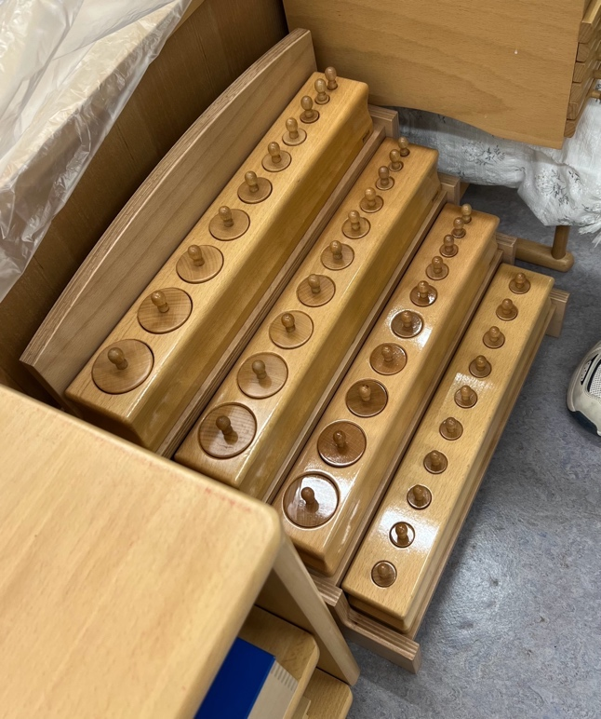A) Each with the same diameter, decreasing in height successively from tall to short. Each differing in one dimension only: height.
  + B) Each diminishing in diameter successively from thick to thin, while their height remains equal throughout. Each differs in two dimensions: width and breadth.
  + C) Each diminishing successively in diameter from large to small, while rising in height from short to tall. Each differs in three dimensions: while the diameter decreases, the height increases.
  + D) Each diminishing in diameter successively from large to small, while at the same time decreasing in. height like A. Each differs in three dimensions: width, breadth and height, but all increase regularly, if one proceeds from the smallest.

**Presentation #1:** - B Block

1. Show the child where the Blocks are and then show the child how to carry the block; hold the ends with the baby fingers underneath, the fingers behind, and the thumb in front
2. At the table position the block between you and the child with the thickest cylinder to the left - horizontal to the edge of the table
3. Begin from the left of the block and take each cylinder out of the block by grasping the knob with the thumb and first two fingers (pincer grasp); take out the cylinders and place in front of you in random position, placing the tiniest one at the far left of the block so that it will be placed back in first (it is wobbly and often falls over before it is put back into the block)
4. Starting with the cylinder on the far left, grasp the knob and place it into the proper hole in the block
5. Descend it directly down into the hole
6. Continue from left to right with the cylinders
7. When all of the cylinders have been placed into the proper holes pass the block to the child
8. Remove the cylinders for him (for this first presentation only) from left to right with random placement in front of him, and then have him replace them

**Exercise** #1:

* + Same as Presentation #1
  + The child can now work with A, B, C, and D Blocks

Exercise #2:

1. Bring 2 blocks to the table
2. Place the blocks on the table parallel to each other, vertical to the bottom edge of the table
3. Ask the child to remove all of the cylinders from the blocks and place them in between the two blocks
4. Ask the child to replace the cylinders in the blocks

Exercise #3:

1. Bring three blocks to the table
2. Place the blocks in a triangle randomly
3. Ask the child to remove all of the cylinders from the blocks and place them in the center of the triangle
4. Ask the child to replace the cylinders in the blocks

Exercise #4:

1. Bring all 4 blocks to the table
2. Place the blocks in a square
3. Ask the child to remove all of the cylinders from the blocks and place them randomly in the center of the square
4. Ask the child to replace the cylinders in the blocks

Notes:

* + The teacher usually leaves after the Presentation, so that the child can work on the exercises for any length of time
  + Introduce the matching of the cylinders to printed cards: Cylinder Block Sequence Cards

Purpose:

**Direct**

* + Visual discrimination of size

Indirect

* + Preparation for writing (pincer grip for holding a pencil

Control of Error:

* + Inherent in the materials (mechanical)

Age:

* + 2½ years

**Language:**

* + Give language to the child only after he has had much experience with the material
  + You can start with any block for language

1. Tall & short - establishment of quality Taller & shorter - comparative

Tallest & shortest - superlative

1. Thick & thin - establishment of quality Thicker & thinner - comparative

Thickest & thinnest - superlative

1. No language
2. Large & small - establishment of quality Larger & smaller - comparative

Largest & smallest - superlative

**3 Period Lesson for Establishment of Quality**

* Refer to the example in the beginning of the manual - 3 Period Lesson
* Work in brevity and simplicity; a final touch to the child's experience
* Bring the block from which the language is to be given, to the table
* Take out the two extremes (i.e. Thick and thin)
* Set the block aside

Block A - tall and short Block B - thick and thin Block C - no language Block D - large and small

**3 Period Lesson on Comparatives**

* Refer to the example in the beginning of the manual - 3 Period Lesson
* Work in brevity and simplicity; a final touch to the child's experience
* Bring the block from which the language is to be given, to the table
* Take out two cylinders close to each other
* Set the block aside

Block A - taller and shorter Block B - thicker and thinner Block C - no language Block D - larger and smaller

3 Period Lesson on Superlatives

* Refer to the example in the beginning of the manual - 3 Period Lesson
* Work in brevity and simplicity; a final touch to the child's experience
* Bring the block from which the language is to be given, to the table
* Take out three cylinders in a row
* Set the block aside

Block A - tallest and shortest Block B - thickest and thinnest Block C - no language

Block D - largest and smallest

Confirmation of Relativity

* The child has now established the quality, the comparative and the superlative
* The child has mastered the language
* This game is for those children who have enough self confidence
* Those children who are unsure of themselves and the concepts make think that this game is like a trick question and they may become confused or upset
* Using block B take out the first three cylinders starting with the thinnest
* Ask the child "which is the thinnest?" (the child should point to the thinnest)
* Put the thinnest back into the block and take the next cylinder in the block, placing it on the left of the two sitting on the table
* Ask the child again "which is the thinnest?" (the child should point to the thinnest)
* Put the thinnest back into the block and take the next cylinder in the block, placing it to the left of the two sitting on the table
* Repeat until the cylinders are all back into the block
* Repeat with the thickest
* You can also take all of the cylinders out of the block and ask for the thinnest or thickest, place the one that the child identifies back into the block
* Can also alternate asking for the thinnest and the thickest

###### Pink Tower

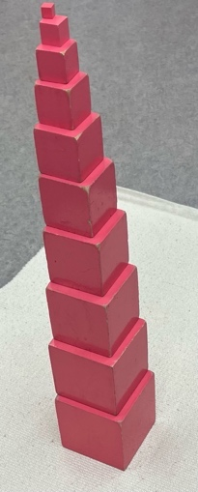

Materials:

* Ten cubes, pink in color, differing in length, width and height. Their sizes grow progressively, in the algebraic series to the third power (1 cm) to the power of 3.

**Presentation #1:** - Build the Tower - Simple

1. Ask the child to set out a mat
2. Go to the Pink Tower with the child, identify it, and show the child how to hold the cubes (one hand holds the top, the thumb on the front, and the fingers down the back; as the cubes get bigger place the other hand underneath to catch it if it should fall) ,.
3. You and the child carry the cubes to the mat one at a time
4. At the mat place the cubes randomly
5. When all of the cubes are on the mat, kneel down at the mat beside the child and begin building the Pink Tower
6. Locate the largest cube from the group and place it in the center of the mat
7. Then from the existing cubes locate the largest cube
8. Using the same grasp as when carrying the cubes to the mat, place the cube straight down on top of the largest cube - directly in the middle
9. Continue choosing the next smaller cube to place on top of the tower being built
10. About half way through building the Tower you should get up off your knees and finish building the Tower (a small child can't kneel and place the last few cubes properly due to their height)
11. Once the Tower is built, walk around it, look at each side, then stand over the top and take a bird's eye view
12. Come back to the front of the mat and take the cubes off one by one and set them randomly on the mat
13. Invite the child to build it
14. When the child is finished, help the child take the cubes back to the shelf one at a time, carrying them properly

Exercise #1:

* + Same as in Presentation #1
  + The child can color the Pink Tower Activity Card

**Presentation #2:** - Build the Tower - Cornered

1. This should only be presented after the child has built it in the simple form correctly many times
2. Have the child take the Pink Tower to a mat that has been laid out
3. Build the Pink Tower Cornered using the same mechanics as in exercise #1; take the largest cube, then take the smaller cube and place it directly on the far left corner, line up the back left corner, run hands along the two edges where the cube actually meets, to smooth the edges
4. Repeat this procedure for each cube until it has been built
5. When finished, walk around the tower, pause at the corner, look at it, then stand above it and take a bird's eye view
6. Stand at the front of the mat, take the smallest cube and place on the top of the largest cube at the far right back corner (it should fit on the lip of the cube if the tower has been built and cornered precisely)
7. Slide the cube towards you, and then to the left (use the index finger to slide it along the cube)
8. Continue all the way up the Tower - precisely and slowly
9. Take the Tower down and then invite the child to build it cornered and then slide the smallest cube as you did

Exercise #2:

* + Same as in Presentation #2

Purpose:

**Direct**

* + Visual discrimination of difference in dimension
  + Muscular control of hand and arm

Indirect

* + Education of voluntary movement
  + Preparation of the hand
  + Preparation for sense of relative sizes and numerical cubes
  + Preparation of the mathematical mind

Control of Error:

* + Within the child (the visual disharmony will become obvious, eventually)

Age:

* + 2½ years

**Language:** - 3 Period Lesson

* + Establish quality - large and small
  + Comparative - larger and smaller
  + Superlative - largest and smallest

Games:

1. **Building the Pink Tower at a Distance**
   1. This game can be played before the child is given a language lesson because there is no language for this game
   2. Set up 2 mats that are quite far from each other in the classroom
   3. Have the child bring the Pink Tower to one mat and set the cubes on the mat in random order
   4. Ask the child to build the Pink Tower on the other mat by taking 1 cube at a time and walking over to the other mat to build it there
   5. This game will help the child to keep the memory for discrimination of size
2. The One Just....
   1. This game can't be played until the language has been given to the child
   2. Have the child set out two mats (far distance away)
   3. Have the child place the cubes of the Tower on mat #1 (not built, just distributed over the mat)
   4. Take a cube (randomly) from mat #1 and take it over to mat #2 with the child
   5. At mat #2, ask the child to bring you a cube from mat #1 that is just larger, or just smaller than the cube that you have in your hands (this will depend on the cube you have selected; if you've chosen the largest cube you will have to ask for the one just smaller)
   6. When the child returns place your cube on the mat and then have the child place his cube on top of it; this will offer confirmation of the size of the child
   7. When all of the cubes have been transferred from mat #1 to mat #2, the child can put the Pink Tower back on the shelf

Extension Lessons:

1. Matching Cubes to Printed Cards: Pink Tower Cards (Cornered) Pink Tower Cards (Centered)
2. If the child has been presented with the Brown (Broad) Stair, they can now use the two materials together.

Pink Tower & Broad Stair Pattern Cards - Set 1 Pink Tower & Broad Stair Pattern Cards - Set 2 Pink Tower & Broad Stair Pattern Cards - Set 3

**Personal Notes:**

###### Brown Stairs

**Materials:**

* + Ten prisms of the same length, brown in color, differing in breadth and height. They grow in size progressively in the algebraic series of the second power, sides 1cm squared - 10cm squared.

**Presentation #1:** - Building the Stair

1. Ask the child to roll out a mat
2. At the shelf introduce the brown stair by name and then show the child how to carry the

prisms (fingers at back, thumb at the front, the palm is above the prism; when the

prisms get heavier the other hand should be held underneath the prism in case it should fall) ••

1. With the child carry the prisms one at a time to the mat and set them down randomly
2. Look for the broadest prism, holding it as described above, position it at the far center back of the mat
3. Look at the prisms remaining and find the broadest one, place it in front of the broadest one already placed
4. Using your fingers butt it up against the first one placed
5. Run the fingers along both sides of the prisms to make sure that they are properly aligned; repeat with the remaining prisms
6. When finished look at both sides, then take it apart
7. Invite the child to build the brown stair
8. Take it apart, and then return the prisms to the shelf

**Exercise #1:**

* + Same as in Presentation #1
  + Match the prism to printed cards - Brown Stair Cards Cornered or Centered
  + The child can color the Broad Stair Activity Card

**Presentation #2** - Showing the Unit of Difference

1. The child should have a lot of time to work with the brown stair before this presentation is given
2. Ask the child to build the brown stair on a mat
3. Take the narrowest prism (holding each end of the prism with the index fingers)
4. Place the prism on top of the second prism and butt it up against the third prism, take your hands away from it and look at it
5. Pick the prism up and place it on top of the third prism and butt it up against the fourth prism, take hands away from it and look at it
6. Repeat until the prism has been placed on the ninth prism (never place it on the very top prism)
7. Return the narrowest prism to its original position
8. Invite the child to have a turn
9. Take it apart and then return the prisms to the shelf

Exercise #2:

* + Same as in Presentation #2

Purpose:

**Direct**

* + Visual discrimination of size
  + Muscular development of grip of hand

Indirect

* + Preparation of the mathematical mind

Control of Error:

* + Within the child (visual disharmony will be perceived, eventually)

Age:

* + 2½ years

**Language:** - 3 Period Lesson

* + Establish quality - broad and narrow
  + Comparative - broader and narrower
  + Superlative - broadest and narrowest

Games:

1. Building the Brown Stair at a Distance
   1. This game can be played before the child is given a language lesson because there is no language for this game
   2. Set up 2 mats that are quite far from each other in the classroom
   3. Have the child bring the Brown Stair to one mat and set the prisms on the mat in random order
   4. Ask the child to build the Brown Stair on the other mat by taking 1 prism at a time and walking over to the other mat to build it there
   5. This game will help the child to keep the memory for discrimination of size
2. The One Just....
   1. This game can't be played until the language has been given to the child
   2. Have the child set out two mats (far distance away)
   3. Have the child randomly place the prisms of the Stair on mat #1
   4. Take a prism (randomly) from mat #1 and take it over to mat #2 with the child
   5. At mat #2, ask the child to bring you a prism from mat #1 that is just broader, or just narrower than the prism that you have in your hands (this will depend on the prism you have selected; if you've chosen the broadest prism you will have to ask for the one just narrower)
   6. When the child returns place your prism on the mat and then have the child place his prism on top of it; this will offer confirmation of the size of the child
   7. When all of the prisms have been transferred from mat #1 to mat #2, the child can put the Brown Stair back on the shelf

###### Red Rods

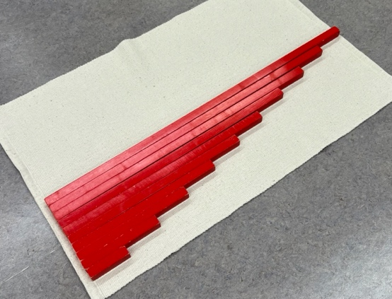Materials:

* + - Ten rods, red in color, differing in one respect: length (from 10 cm to 1m).

**Presentation #1:** - Building the Red Rods

1. Ask the child to set out a mat
2. Introduce the red rods by name, and show the child where they are kept on the shelf
3. Show the child how to carry the red rods; the rods are grasped with one hand for the smaller ones which up till rod #5 can be carried one in each hand (two taken to the mat at one time) .
4. Rods #5-10 have to be carried with two hands grasping the rod and holding it in front of you vertically so that you don't hit anyone with it
5. Help the child take the rods to the mat
6. At the mat take the longest rod, and place it at the far back left corner of the mat
7. Once placed, keep the left hand at the left end of the rod
8. With the right hand, use your first two fingers (index and middle) and stroke the rod all of the way from the left end of the rod to the right end of the rod with a slow flowing movement; at the end make a clear stop
9. Remove both hands from the rod (*ensure that the left end of the rods are aligned before stroking them)
10. Take the longest rod from the rods remaining and place it up to the rod already in place, butt it up against the rod keeping the left hand at the left of the rod
11. Use your right fingers (index and middle) to stroke the rod until the far right end of the rod
12. Repeat until the last rod is in place
13. Once finished, look at it, then take it apart
14. Invite the child to build the red rods
15. Take the rods apart, then return them to the shelves

Exercise #1:

* + Same as in Presentation #1
  + The child can color the Red Rod Activity Card to take home

**Presentation #2** - Showing the Unit of Difference

1. Ask the child to build the red rods on a mat
2. Take the shortest rod and place it at the end of the second rod so that it fills the space . between the second and third rod, remove the hands and look at it
3. Pick it up and move it to the third rod, remove hands and look at it
4. Continue until you reach rod #9; do not put it at the end of the longest rod
5. Return it to its original position
6. Invite the child to have a turn; then return the rods to the shelf

**Exercise #2:**

* + Same as in Presentation #2. The child is then ready to explore patterns.

**Purpose:**

Direct

* + Visual discrimination of length
  + Development of sense of visual distance
  + Development of muscular activity

**Indirect**

* + Preparation for number work

**Control of Error:**

* + Within the child (visual disharmony will be perceived, eventually)

**Age:**

* + 3 to 3½ years

**Language:** - 3 Period Lesson

* + Establish quality - long and short
  + Comparative - longer and shorter
  + Superlative - longest and shortest

**Games:**

1. Building the Red Rods at a Distance
   * This game can be played before the child is given a language lesson because there is no language for this game
   * Set up 2 mats that are quite far from each other in the classroom
   * Have the child bring the Red Rods to one mat and set the rods on the mat in random order
   * Ask the child to build the Red Rods on the other mat by taking 1 rod at a time and walking over to the other mat to build it there
   * This game will help the child to keep the memory for discrimination of size
2. The One Just....
   * This game can't be played until the language has been given to the child
   * Have the child set out two mats (far distance away)
   * Have the child randomly place the rods on mat #1
   * Take a rod (randomly) from mat #1 and take it over to mat #2 with the child
   * At mat #2, ask the child to bring you a rod from mat #1 that is just longer, or just shorter than the rod that you have in your hands (this will depend on the rod you have selected; if you've chosen the longest you will have to ask for the one just shorter)
   * When the child returns place your rod on the mat and then have the child place his rod on top of it; this will offer confirmation of the size for the child
   * When all of the rods have been transferred from mat #1 to mat #2, the child can put the Red Rods back on the shelf

#### Knobless_Cylinders

**Materials:**

* + Four boxes, each containing a set of cylinders in the dimensions of the four cylinder blocks, each set a specific color: A blue, 8 red, C green, D yellow.

**Presentation #1:**

Phase #1 - Comparing Heights

1. Introduce the child to the knobless cylinders by name and where they are kept on the shelf, show the child how to carry the box (thumbs on top and.the fingers underneath)
2. With the child bring the red, green, and yellow boxes to the table
3. Set the boxes in the top right hand corner of the table (left to right: red, green, yellow)
4. ***Note:*** In general the cylinders are graded from left to right starting with the largest surface.
5. Place the red box between you and the child
6. Remove the lid and place it down with the color/painted surface facing up)
7. Take the cylinders out one at a time placing them down randomly on the table with the pincer grip of your right hand
8. Set the box aside
9. Grade the cylinders from thickest to thinnest, left to right
10. Mix them up randomly and invite the child to grade them
11. Bring back the red box and place the cylinders back in the box with the pincer grip
12. Replace the lid and place the box in its original position on the table

***From this point on, you will always bring the box forth, the child will take the cylinders out of the box and place them randomly on the table. You will then return the box to its original position. You will start the grading process by placing the first cylinder where it is to be graded, and then ask the child to finish the grading for you. When need be, you will bring the box forward again and have the child return the***

.***cylinders back into the box. You will then place the box back in its original position.***

* + Grade the green cylinders
  + Leave them on the table graded
  + Grade the red cylinders behind the green cylinders
  + Ask the child, "Are there any between the two series that have the same height?"
  + Put the green cylinders away and leave the red cylinders out
  + Grade the yellow cylinders in front of the red cylinders
  + Ask the child, "Are there any between the two series that have the same height?"
  + Put the red cylinders away, and leave the yellow cylinders out
  + Grade the green cylinders in front of the yellow cylinders
  + Ask the child, "Are there any between the two series that have the same height?"

**REVERSE from here on in;** take the last right cylinder from the front graded line and place it behind the first left cylinder in the second graded line

* + Reverse the green cylinders to go behind the yellow cylinders
  + Ask the child, "Are there any between the two series that have the same height?"
  + Leave both the yellow and the green cylinders out
  + Grade the red cylinders in front of the yellow cylinders
  + Ask the child, "Are there any between the two series that have the same height?"
  + Reverse the red cylinders to go behind the green cylinders
  + Ask the child, "Are there any between the two series that have the same height?"
  + Collect 2 mirrors (there should be some available in the Practical Life area) and have some fun looking at all of the cylinders through the mirrors
  + The child can make designs with the three grades of cylinders

Phase #2 - Comparing Heights with Blue

* + Grade the blue cylinders
  + Grade red in front of blue
  + Ask the child, "Are there any between the two series that have the same height?"
  + Reverse the red cylinders to go behind the blue cylinders
  + Ask the child, "Are there any between the two series that have the same height?"
  + Put the red cylinders away
  + Grade green in front of blue
  + Ask the child, "Are there any between the two series that have the same height?"
  + Reverse the green cylinders to go behind the blue cylinders
  + Ask the child, "Are there any between the two series that have the same height?"
  + Put the green cylinders away
  + Grade the yellow cylinders in front of the blue cylinders
  + Ask the child, "Are there any between the two series that have the same height?"
  + Reverse the yellow cylinders to go behind the blue cylinders
  + Ask the child, "Are there any between the two series that have the same height?"
  + Grade the red cylinders in front of the blue cylinders
  + Ask the child, "Are there any between the three series that have the same height?"
  + Reverse the red cylinders to go behind the yellow cylinders
  + Ask the child, "Are there any between the two series that have the same height?"
  + Grade green cylinders in front of the blue cylinders
  + Ask the child, "Are there any between the three series that have the same height?"
  + Reverse the green cylinders to go behind the red cylinders
  + Collect 2 mirrors and have some fun looking at all of the cylinders through the mirrors
  + The child can make designs with the three grades of cylinders
  + Put all of the cylinders back into the boxes and return to the shelf

**Exercise** #1:

* + Same as in Presentation #1
  + Introduce the Knobless Cylinder Sequence Cards

**Presentation #2:**

Phase #1 - Comparing Surfaces

1. Grade the red cylinders
2. Grade the green cylinders directly on top of the red cylinders
3. Ask the child, "Are there any between the two series that have the same surface?"
4. Take the green cylinders off of the red cylinders and place in front of them
5. Reverse and superimpose the green to the red with the largest cylinder (regardless of color) always being on the bottom* (superimpose means to place or lay over or above something)
6. Ask the child, "Are there any between the two series that have the same surface?"
7. Take the green cylinders away from the red, and put the green cylinders away
8. Grade the yellow cylinders directly on top of the red cylinders
9. Ask the child, "Are there any between the two series that have the same surface?"
10. Take the yellow cylinders off of the red cylinders and place them in front of them
11. Reverse and superimpose the yellow to the red
12. Ask the child, "Are there any between the two series that have the same surface?"
13. Take the yellow cylinders away from the red, and put the red cylinders away
14. Grade the green cylinders directly on top of the yellow cylinders
15. Ask the child, "Are there any between the two series that have the same surface?"
16. Take the green cylinders off of the yellow cylinders and place them in front of them
17. Reverse and superimpose the green to the yellow
18. Ask the child, "Are there any between the two series that have the same surface?"
19. Take the green cylinders away from the yellow cylinders, and put both sets of cylinders away

Phase #2 - Comparing Surfaces with Blue

1. Superimpose, then reverse superimpose
2. Grade the blue cylinders
3. Grade the red cylinders directly on top of the blue cylinders
4. Ask the child, "Are there any between the two series that have the same surface?"
5. Take the red cylinders off of the blue cylinders and place in front of them
6. Reverse and superimpose the red to the blue with the largest cylinder regardless of color always being on the bottom
7. Ask the child, "Are there any between the two series that have the same surface?"
8. Take the red cylinders away from the blue, and put the red cylinders away
9. Grade the green cylinders directly on top of the blue cylinders
10. Ask the child, "Are there any between the two series that have the same surface?"
11. Take the green cylinders off of the blue cylinders and place them in front of them
12. Reverse and superimpose the green to the blue
13. Ask the child, "Are there any between the two series that have the same surface?"
14. Take the green cylinders away from the blue, and put the green cylinders away
15. Grade the yellow cylinders directly on top of the blue cylinders
16. Ask the child, "Are there any between the two series that have the same surface?"
17. Take the yellow cylinders off of the blue cylinders and place them in front of them
18. Reverse and superimpose the yellow to the blue
19. Ask the child, "Are there any between the two series that have the same surface?"
20. Take the yellow cylinders away from the blue cylinders, and put both sets of cylinders away

Exercise #2:

* + Same as in Presentation #2, combine Phase #1 and Phase #2 using all cylinders
  + Introduce the child to the Knobless Cylinder Pattern Cards Set #1 and Set #2
  + Introduce the child to the Knobless Cylinder Comparison Cards

Purpose:

**Direct**

* + To observe and compare different series with each other

Indirect

* + To arrive at clear ideas about dimensions and their interplay

Note:

* + The child should have plenty of experience with the Pink Tower, Broad Stair, Red Rods and Cylinder Blocks prior to this lesson; the mind needs to be prepared

Age:

* + 4½ years

###### Binomial Cube

- - • ... ••

**Materials:**

* + A cube composed of 8 wooden blocks which fit together in a binomial pattern, representing the cube of two numbers, (a+ b).

**Presentation #1:**

Part #1 - Building in the Box - Simple

1. Introduce the child to the binomial cube, show him where it belongs on the shelf and how to carry it (thumbs on top holding the lid in place, and the fingers underneath carrying the weight of the box)
2. Once seated show the child how to open and close the box
3. Make sure that the box is situated so that the two hinges are directed towards the bottom right hand corner of the table
4. With both hands, remove the lid and place it so that the top left hand corner of the lid is touching the bottom left hand corner of the box
5. The red cube pictured on the lid should be in the top left hand corner of the lid
6. Open the right side of the lid using the thumb and index finger from both hands to lower the side down
7. Use the same procedure to lower the side facing you
8. The lid should now be in the corner created by the lowered sides
9. Close the box in the same manner as you opened it, and replace the lid
10. Invite the child to open and close the box
11. Open the box, and remove the prisms and the cube of

the top layer and place them on the table without changing the heights of them - simple transfer to the table

1. Keep the top layer of prisms and cube together in one small area on the table ·
2. Take out the next layer of prisms and cube as you did the top layer, except place these ones in a small area separate from the top layer
3. Starting with the red cube replace the bottom layer into the box
4. Build the top layer in the box
5. Once built, remove it in the same manner and invite the child to build the cube

Part #2 - Building in the Box - Difficult

1. Remove the prisms and the cubes from both layers onto the table mixing both layers together as well as altering the heights of them
2. Build the cube into the box
3. Invite the child to take the prisms and cubes out of the box mixing up both layers together as well as altering the heights
4. Invite the child to build the cube inside the box
5. Invite the child to close the sides and replace the lid

**Exercise #1:**

* Same as in Presentation #1, Part 1 and Part 2

**Exercise #2:** - Building Outside of the Box

1. This exercise is only given to the child when he has had time to work with and experience the Binomial Cube
2. Ask the child to take and mix up all of the prisms and the cubes
3. Set the box aside so the child cannot see the pattern on the lid
4. Invite the child to build the binomial cube outside of the box

**Exercise #3:** - Moving Layers

1. The child has to be able to build the cube successfully outside of the box without the box being visible
2. Show the child how to slice and slide apart the front and back layer as well as the right and left side layers
3. Invite the child to slice and slide apart the layers as you did

**Presentation #2:** - Making a Parade

1. Ask the child to remove the cubes and prisms and mix them up on the table, set the box aside
2. Show the child how to make a parade with the binomial cubes and prisms

**Exercise #1:** - Building Layers Outside of the Box

1. Have the child remove the prisms and cubes from the box, mix them up on the table and set the box aside
2. Have the child build the first layer on the table (outside of the box)
3. Have the child build the second layer on the table (outside of the box)
4. Have the child mix the cubes and prisms up and then build the cube in the box

**Purpose:**

**Direct**

* + Build a cube

**Indirect**

* + Introduction to algebra (because it is the concrete proof of two formulas (a+b cubed)

**Control of Error:**

* + Within the child (visual disharmony will be perceived)

Age:

* + 3½ years+

**Personal Notes:**

###### Trinomial Cube

Materials:

* + A cube composed of twenty-seven wooden blocks which fit together to form the cube of (a+ b + c).

Presentation #1:

**Part #1** - Building in the Box - Simple

This material should only be presented after the child has mastered the binomial cube

1. Introduce the child to the trinomial cube, show him where it belongs on the shelf and how to carry it (thumbs on top holding the lid in place, and the fingers underneath carrying the weight of the box) ••
2. Once seated, show the child how to open and close the box
3. Make sure that the box is situated so that the two hinges are directed towards the bottom right hand corner of the table
4. With both hands, remove the lid and place it so that the top left hand corner of the lid is touching the bottom left hand corner of the box
5. The red cube pictured on the lid should be in the top left hand corner of the lid
6. Open the right side of the lid using the thumb and index finger from both hands to lower the side down
7. Use the same procedure to lower the side facing you
8. The lid should now be in the corner created by the lowered sides
9. Close the box in the same manner as you opened it, and replace the lid
10. Invite the child to open and close the box
11. Open the box, and remove the prisms and the cubes of the top layer of the of the trinomial cube onto the table without changing the heights of the prisms or the cubes (keep the top layer of prisms and cubes together in one small area on the table)
12. Take out the next layer of prisms and cubes as you did the top layer, except place these ones in an area separate from the top layer
13. Take out the bottom layer of prisms and cubes as you did the previous two; also place these ones in a small area separate from the other two layers
14. Build the bottom layer of the cube and prisms in the box starting with the red cube
15. Build the middle layer in the box
16. Build the top layer in the box
17. Once built, remove it in the same manner (one layer at a time and keep the layers separate)
18. Invite the child to build the cube

**Part #2** - Building in the Box - Difficult

1. Remove the prisms and the cubes from the three layers onto the table mixing all three layers together as well as altering the heights of them
2. Build the cube into the box
3. Invite the child to take the prisms and cubes out of the box mixing up all three layers together as well as altering the heights
4. Invite the child to build the cube inside the box
5. Invite the child to close the sides and replace the lid

**Exercise #1**:

* + Same as in Presentation #1, Part 1 and Part 2

**Exercise #2:** - Building Outside of the Box

1. This exercise is only given to the child when he has had time to work with and experience the trinomial cube
2. Ask the child to take and mix up all of the prisms and the cubes
3. Set the box aside
4. Invite the child to build the trinomial cube outside of the box

**Exercise #3:** - Moving Layers

1. The child has to be able to build the cube successfully outside of the box without the box being visible
2. Show the child how to slice and slide apart the front, middle, and back layer as well as the right and left side layers with the middle layer
3. Invite the child to slice and slide apart the layers as you did

**Presentation #2:** - Making a Parade

* + Ask the child to remove the cubes and prisms and mix them up on the table
  + Show the child how to make a parade with the cubes and prisms

**Exercise #1:** - Building Layers Outside of the Box

1. Have the child remove the prisms and cubes from the box, mix them up on the table and set the box aside
2. Have the child build the first layer on the table (outside of the box)
3. Have the child build the second layer on the table (outside of the box), separate from the first layer
4. Have the child build the third layer on the table (outside of the box), separate from the first two layers
5. Have the child mix the cubes and prisms up and then build the cube in the box

Purpose:

**Direct**

* + Build a cube

Indirect

* + Introduction to algebra (because it is the concrete proof of two formulas (a+b+c cubed)

Control of Error:

* + Within the child (visual disharmony will be perceived)

Age:

* + 4 years+, the child must have mastered the Binomial Cube

Personal Notes:

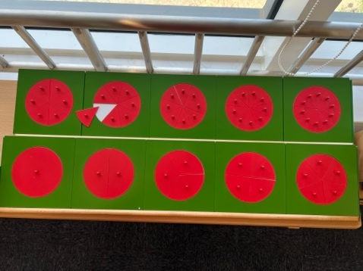Small Metal Inserts

Materials:

* + 1O metal plates, each of which has a circular metal insert 10cm in diameter. One inset is a complete circle. The other circle insets are divided respectively into 2, 3, 4, 5, 6, 7, 8, 9, and 10 parts. Each segment has a small knob for handling. Tray, pad, paper, pencil, and ruler

**Presentation #1:** - Replacing the Segments

1. Bring both trays of insets to the table
2. Place the tray with the frames 1-5 directly in front of you, with the frames 6-10 directly behind it
3. Moving left to right with your pincer grip remove all of the segments from each frame and place it directly in front of the frame that it was just removed from (preserve its position and order); leave a small space between the segments when they are placed onto the table to create the circle
4. Repeat this procedure with frames 2-5
5. Beginning left to right replace the segments into their corresponding frames
6. Take the segments out again in the same manner as above (preserve its position and order) and invite the child to replace the segments into their corresponding frames
7. Take the segments out one by one and place them randomly on the table (mixed up from their frames)
8. Starting with a segment on the far left, replace all of them one by one into their appropriate frames
9. Take the segments out one by one and place them randomly on the table (mixed up from their frames)

1G. Invite the child to replace them one by one into their appropriate frames

Exercise #1:

* + Same as in Presentation #1
  + The child can now work with all of the Small Metal Inset frames

**Presentation #2:** - Placing Segments in to the Half Circle

1. Bring both trays (1-10) segments to the table
2. Take out the second frame and place it on the table (isolation)
3. Take out the left segment (half of the circle) and set it aside
4. Take one of the segments from the third frame and place it into the space on the half circle, look to see if there is enough space for another segment from the third frame
5. Put the segments from the third frame back into the third frame
6. Try to fit segments from the fourth frame
7. Put the segments from the fourth frame away
8. Invite the child to try the fifth frame and so on until the child has tried all of the frames up to and including the tenth
9. The child is now free to isolate the third frame, take out one of the segments and try to fill the space with segments from the fourth frame, then the 5th, 6th, 7th, 8th etc.
10. The child will repeat with each of the different frames in turn

Exercise #2:

* + Same as in Presentation #2

**Presentation #3:** - Combinations in the Half Circle

1. Isolate the half frame on the table and take out the left half, place the segment to the side
2. What combinations of the segments will fill the space? I.e.) a third can be added to the half but there will still be space left so you can try a 6th and 8th segment
3. When the frame is complete, take out the segments and replace them into their proper frames
4. Start to fill the half circle with a segment from the fourth frame
5. Repeat this with the 5th-10th segments

Exercise #3:

* + Same as in Presentation #3

**Presentation #4:** - Creating Designs within the Frames

1. Take frame 1 (the whole circle), isolate it on the table in front of you, remove the inset and place it to the side
2. Make a design with the other segments from the other 9 frames in the empty frame
3. Be creative, you can use all of the segments
4. When the design is finished, replace the segments to their proper frames
5. Invite the child to have a turn

**Presentation #5:** - Creating Designs on the Table

1. Leave all of the frames in place
2. Take out the segments from the frames one at a time, and place them on the table to make a design
3. Return the segments to their frames
4. Invite the child to have a turn

**Presentation #6:** - Creating a Design on Paper

1. The child will most likely be 4+ years old; however the child must be able to hold and use a pencil with control and co-ordination
2. Bring the tray with the pad, paper, and pencil to the table
3. Place the paper onto the pad, place the pencil on the table beside the pad, and set the tray aside
4. Placing the segments down onto the paper one at a time, make your design
5. Holding the segment down by the knob with one hand, use the other hand to trace around the segment with the pencil
6. Once all of the segments have been traced replace the segments back into their proper frames, look at the design
7. Invite the child to have a turn

**Presentation #7:** - Creating a Design on Paper from the Imagination

1. Think about a design for a few moments
2. Take the first needed segment out of its frame and trace it onto the paper, replace the segment back into its frame
3. Take the next needed segment, place it on the paper to further create the imagined design, trace it, then replace into its frame
4. Continue until the design is finished
5. Invite the child to make a design from his imagination

**Presentation #8:** - Creating a Design on Paper from the Imagination

1. Trace a design on paper as in Presentation #7
2. When all of the segments have been traced take the ruler and connect the traced segments
3. You can overlap segments, and you don't have to trace the entire segment

Exercise #3 - #8:

* + Same as in Presentation #3-8

Printable Fraction Cards and Labels - children can use them to create their own fractions with the segments.

Purpose:

**Direct**

* + Visual discrimination of size and shape

Indirect

* + Preparation for geometry and fractions
  + Preparation for elements of design

Control of Error:

* + The frame itself

Age:

* + 2½ - 6 years; it is a progressive exercise and the child needs to have a lot of experience with the material

**Personal Notes:**

***Discrimination of Color***

##### Color Tablets - Box 1

**Materials:**

* + A box containing six tablets of light wood or plastic; one pair each of the three primary colors: red, blue and yellow.

**Presentation #1:** - Primary Colors

1. Open the box and show the child how to handle the tablet. hold the white edge only - do not touch the color
2. Remove the 6 tablets and place them randomly on the table
3. Close the box and set it aside
4. Place the first tablet out and ask the child match it (place them side by side with the white edge on the top and bottom)
5. Place the next color underneath and ask the child to match it
6. Place the third tablet underneath the other tablets and ask the child to match the color
7. Ask the child the names of the colors (if you know that the child does not know the names of the colors proceed with a Three Period Lesson)
8. Mix up the colors and invite the child to match them
9. Ask the child the name of the colors
10. Return the tablets to the box; tell the child that the tablets are always to be mixed up when placed back into the box

**Exercise #1:**

* + Same as in Presentation #1
  + Printable Colar Matching Cards
  + Can introduce Color Books and Color Sorting

**Purpose:**

**Direct**

* + Visual discrimination of color
  + Sensorial training, providing the child with the key to the world of color
  + Development of the chromatic sense

**Indirect**

* + Preparation for art

**Control of Error:**

* + Within the child (visual disharmony will be perceived)

**Age:**

* + 2½ years

##### Colar Tablets - Box 2

Materials:

* + A box containing twenty-two tablets, one pair each: red, orange, yellow, green, blue, purple, pink, gray, brown, black and white.

**Presentation #1:** - Secondary and Tertiary Colors

1. Color box #2 can be given almost directly after color box I; there doesn't need to be a big time lapse
2. Remove from the box the pairs of colors orange, green and purple (secondary colors) and place them randomly on the table, set the box aside
3. Ask the child to match the tablets, then name them
4. Ask the child to mix them up
5. Take from the box the blue, red, and the yellow (primary colors) and mix them in with the orange, green and purple, set the box aside
6. Ask the child to match them, then to name them
7. Leave them matched on the table
8. Take from the box the gray, brown and pink (tertiary colors) and mix them on the table
9. Set the box aside
10. Have the child match the gray, brown and the pink alongside the colors already matched
11. Ask the child to name them
12. Ask the child to mix them all up together
13. Bring from the box the black and the white tablets and mix them in with all of the other mixed tablets, set the box aside
14. Ask the child to match all of the tablets
15. Ask the child to name them all
16. Ask the child to help you put all of the tablets back into the box mixed up

Exercise #1:

* + Same as in Presentation #1
  + Printable Color Matching Cards

**Color Box 2** - **Layout** & **Match**

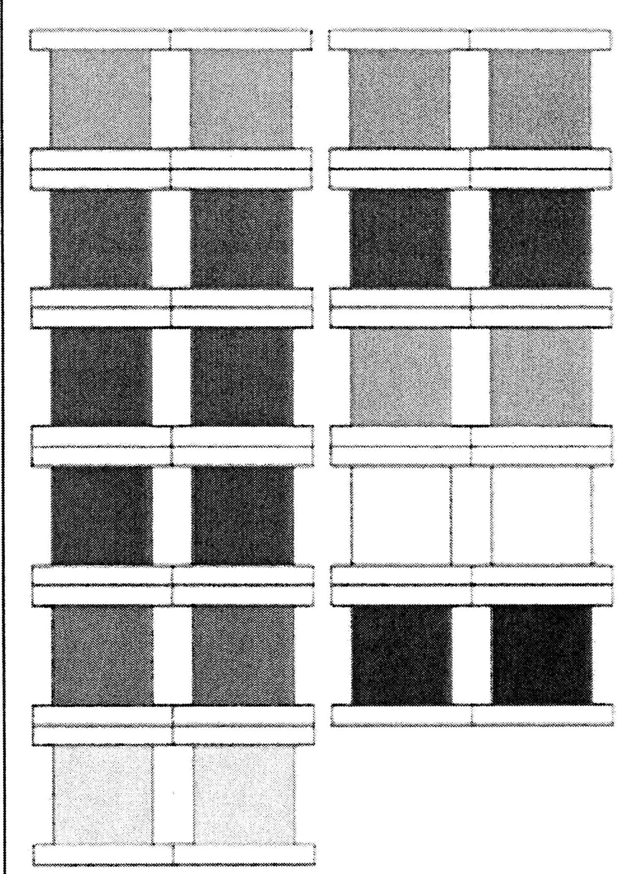

Purpose:

**Direct**

* + Visual discrimination of color
  + Sensorial training, providing the child with the key to the world of color
  + Development of the chromatic sense

Indirect

* + Preparation for art

Control of Error:

* + Within the child (visual disharmony will be perceived)

Age:

* + 2½ years

Games:

1. **Matching at a Distance**
   1. Three children maximum can play this game at one time
   2. Open the color box
   3. Remove one tablet of each color and mix them up on the table
   4. Take the box to another table and remove the remaining tablets, mix them up on the table
   5. You and the child return to the first table
   6. Ask the child to pick a color tablet, place it aside (isolate it)
   7. Ask the child to go to the other table, locate the color tablet that matches and bring it back to match it to the first tablet
   8. The game ends when all of the color tablets are matched
2. Bringing Tablet to Object
   1. Maximum of three children at a time
   2. Take out all of the tablets and mix them up on the table
   3. Take a walk through the environment with the children
   4. Point to an object in the environment and ask a child to retrieve the tablet from the table that matches that particular color
   5. Have the child bring the tablet to the object and place it down beside it
   6. Walk through the environment and give the next child a color to match a tablet to
   7. When finished the children need to collect all of the tablets from the environment and replace them back into the color box
3. Bringing Object to Tablet
   1. Maximum of three children at a time
   2. Take out all of the tablets from the box and mix them up on the table
   3. Ask the child to pick one tablet, then ask the child to go and find something in the environment that matches the color that he has just isolated and bring it back to the table
   4. When all of the tablets are matched up to something the children must return the objects in the environment
4. Match Tablet to Picture Cards

* Colar cards (can be used in book format)
* Color sorting cards

Note:

* Color Box 2 should be used in the games first before Color Box 3 is presented, as box 3 has many more gradations of hues that are more difficult to perceive; the children need time to refine their visual discrimination

#### Color Tablets - Box 3



Materials:

* One box with nine compartments, each containing seven tablets in gradations of each of the colors in box 1 and 2, except black and white.

Presentation #1:

The child must have experience with the Colar box I & 2

* 1. Ask the child to remove the blue tablets and mix them on the table, set the box aside
  2. Casually mention to the child that you are looking for the two most different (look for the darkest and the lightest)
  3. Place the darkest at the top of the table and the lightest farther down the table (with the white edges of the tablets facing left and right)
  4. Gradee the remaining tablets from darkest to lightest slotting them in between the two already placed on the table
  5. Mix them up
  6. Invite the child to grade the tablets
  7. Once the child has graded them, he can:
     1. Put it back into the box mixed up and then take out another color to grade
     2. Set it aside and then grade the next color, keeping the tablets that he grades out beside each other in a line
     3. Grade them simultaneously in one line; dark green, dark blue, lighter green, lighter blue, etc.
     4. Grade in designs with the colors

Exercise #1:

* Same as in Presentation #1
* Printable Colar Grading Cards

Language:

* The child needs time to experience the hues before the language is given
* Dark & light - establish a quality
* Darker & lighter - comparative
* Darkest & lightest - superlative

Purpose:

**Direct**

* Visual discrimination of color
* Sensorial training, providing the child with the key to the world of color
* Development of the chromatic sense

Indirect

* Preparation for art

Control of Error:

* Within the child (visual disharmony will be perceived)

**Age:**

* 2½ years

**Games:**

1. **Matching at a Distance**
   * Three children maximum can play this game at one time
   * Open the color box
   * Remove one tablet of each color and mix them up on the table
   * Take the box to another table and remove the remaining tablets, mix them up on the table
   * You and the child return to the first table
   * Ask the child to pick a color tablet, place it aside (isolate it)
   * Ask the child to go to the other table, locate the color tablet that matches and bring it back to match it to the first tablet
   * The games ends when all of the color tablets are matched
2. **Bringing Tablet to Object**
   * Maximum of three children at a time
   * Take out all of the tablets and mix them up on the table
   * Take a walk through the environment with the children
   * Point to an object in the environment and ask a child to retrieve the tablet from the table that matches that particular color
   * Have the child bring the tablet to the object and place it down beside it
   * Walk through the environment and give the next child a color to match a tablet too
   * When finished the children need to collect all of the tablets from the environment and replace them back into the color box
3. **Bringing Object to Tablet**
   * Maximum of three children at a time
   * Take out all of the tablets from the box and mix them up on the table
   * Ask the child to pick one tablet, then ask the child to go and find something in the environment that matches the color that he has just isolated and bring it back to the table
   * When all of the tablets are matched up to something the children must return the objects in the environment

**Personal Notes:**

## Discrimination of Shape

##### Geometry Cabinet

Materials:

* + A wooden cabinet with six drawers, each painted blue inside and containing six squares of wood. Each wooden figure has a figure cut out, painted blue, with a knob in the center by which to hold it. When the cut­ out figure is lifted, the blue background of the drawers shows the shape of the cut-out.

**Drawer 1** - Circles; six circles varying in diameter decreasing from 10 cm to 5 cm

**Drawer 2** - Rectangles; one square (10 x 10 cm) and five rectangles decreasing by one cm in width consecutively

**Drawer 3** - Triangles; three isosceles, right, acute, and obtuse angled; three scalene, right, acute and obtuse

**Drawer 4-** Polygons; pentagon, hexagon, heptagon, octagon, nonagon, decagon

**Drawer 5** - Curvilinear figures; curvilinear triangle, quatrefoil, oval, ellipse

**Drawer 6** - Quadrilaterals; rhombus, parallelogram, trapezium, right-angled trapezium

On top of the cabinet, a demonstration tray containing a circle, a square and an equilateral triangle. The three remaining spaces have plain squares of wood.

**Presentation #1:** - Presentation Tray

1. Have the child carry the presentation tray to the table
2. Holding the inset by the knob with the left hand pick up the inset and angle it slightly
3. With the right first two fingers trace around the edge of the square clock wise (trace with definite, crisp, clear, and deliberate movements, trace right on the edge)
4. Set the inset down on the blank square right above it
5. With the right two fingers trace the frame of the square counter clockwise (gives the character of the square to the fingertips)
6. Pick up the inset with the left hand and replace it in the frame
7. Proceed to the circle and repeat the same procedure
8. Repeat the same with the triangle

**Exercise #1**:

* • Same as in Presentation #1

**Presentation #2:** - Working with the Drawers

* 1. Have the child take the first drawer to the table (circles)
  2. Take out the top left circle with the left hand, trace it with the right hand, set it down on the table randomly above the drawer
  3. Go to the next circle - take it out with the left, trace it with the right, and set it down randomly on the table
  4. Repeat until all of the circles have been removed, traced, and placed randomly on the table
  5. To replace the circles start with the far left circle from those on the table, pick it up, trace it (clock wise), set it off to the side (isolate it), and then go to the frames and visually discriminate the appropriate circle, trace (counterclockwise) the frame that you think is appropriate to the inset that you have isolated, then insert the inset
  6. Repeat with the next far left inset

**Exercise #2:**

* + - Same as in Presentation #2
    - The child is now to work with all of the 6 drawers in turn

**Language:** - Trace It, Say It

1. The language is not given immediately, the child needs time to work with and sensorially experience the material
2. You do not have to give all of the children all of the language of each drawer
3. The children will pass the language on through each other; but it is important that you ensure that they do have the correct language
4. You can do quick checks with the children when they are using the trays, and as always

- listen carefully to what the children are saying to each other, as they will tell each other the language

1. You want the child to trace the shape and say the name of it

**Layout of the Trays**

Presentation tray - square, circle, triangle

Tray 1 -Circles: confirm with the child one day when he is using the tray

Tray 2 -Rectangles: after the child experiences the tray you can point out the square and the rectangles

Tray 3 -Triangles: 2 part presentation at different sittings

* 1. Sides - isosceles/ scalene/ equilateral
  2. Angles + sides - acute / obtuse / right

Tray 4 -Polygons: 2 part presentation at different sittings

1. The first three polygons: pentagon, hexagon, heptagon
2. The last three polygons: octagon, nonagon, decagon

Tray 5 -Curvilinear: curvilinear triangle, quatrefoil, oval, and ellipse

Tray 6 -Quadrilaterals: rhombus, parallelogram, trapezium, right-angled trapezium

Introduce the child to the Geometry Cabinet Shapes 3-Part Cards, Geometry Cabinet Control Booklet, the Geometry Cabinet Worksheets, Geometric Shape Sorting

**Purpose:**

**Direct**

* Visual & muscular discrimination of shape
* Visual training for recognition of geometric shapes

**Indirect**

* Preparation for writing (hence the reason for tracing both clock wise and counter clock wise)

**Control of Error:**

* Inherent in the materials

**Age:**

* 2½ to 5 years

**Personal Notes:**

###### Constructive Triangles

**Presentation:**

* The child is shown how to take a put together triangles to form other figures
* There is a succession of exercises
* What you do with one box is different than what you do with another box
* Showing the child how to fit together triangles
* Should be done on a table
* All the properties of a presentation should be at the forefront of your mind; crisp, clear, deliberate movement

**Exercise:**

* The child will make discoveries on his own
* Encourage experimentation and exploration with the different boxes
* If the child is not using the materials as presented it is perfectly fine as long as the child is not misusing the
* Don't stifle their exploration and discovery

**Purpose:**

* They are practical exercises in plane geometry
* A sort of puzzle enabling one to see what type of figures arise when 2 or more triangles are joined in different ways
* You cannot do the constructive triangle work without the experience and language of the geometry cabinet (the constructive triangles will be meaningless if they don't have the basis of geometry and language)

**Control of Error:**

* Inherent in the materials (black lines)

**Age:**

* 3½ to 6 years; if completed the geometry cabinet

**Personal Notes**

**Materials:**

* + 2 Gray scalene right-angled

triangles with a black line along the hypotenuse

* + 2 green isosceles right-angled

triangles with a black line along the hypotenuse

* + 2 yellow equilateral triangles with a black line one of the side
  + 2 green scalene right-angled triangles with a black line on the longer side enclosing the right angle
  + 2 yellow isosceles right-angled triangles with a black line on one of the sides enclosing the right angle
  + 2 yellow scalene right-angled triangles with a black line on the shortest side enclosing the right angle
  + 1 red scalene right-angled triangle with a black line along the longer side enclosing the right angle
  + 1 red scalene obtuse-angled triangle with a black line along the side opposite the obtuse angle

**Presentation:**

1. Show the child the material and where it is kept on the shelf, name it for the child and show him how to carry it
2. At the table remove from the box:
   * 2 gray scalene right-angled triangles
   * 2 yellow equilateral triangles
   * 2 green isosceles right-angled triangles
3. Set them on the table mixed up, and set the box aside
4. Take the 2 gray triangles and match the black lines up, put the figure together to form a rectangle and then slide it up to the top left hand corner of the table
5. Find the 2 green isosceles right-angled triangles, match up their black lines to form a square, and then slide the figure up to the top left hand corner of the table beside the first figure
6. Find the 2 yellow equilateral triangles and match their black lines to form a rhombus, slide the figure up to the top of the table beside the other two figures
7. Mix the figures up and invite the child to make the figures
8. Bring forth from the box:
   * 2 green scalene right-angled triangles
   * 2 yellow isosceles right-angled triangles
9. Set the box aside

1*D.* Invite the child to make the new figures

1. When all the figures are made mix them up
2. Bring forth from the box:
   * 2 yellow scalene right-angled triangles
3. Close the box and set it aside
4. Invite the child to make the matches for all of the figures
5. Mix them all up
6. Bring forth the box and take out:
   * 2 red triangles (scalene right-angled triangle and the scalene obtuse angled triangle)
7. Invite the child to make all of the figures
8. Show the child how to replace them in the box in reverse order

**Exercise** #1:

* + Same as in Presentation #1
  + Printable Constructive Triangles - Rectangular Box A

Purpose:

**Direct**

* + Show by sensorial experience that different triangles join together and form 4 sided figures or other triangles

Indirect

* + Preparation for geometry; the child absorbs the fact that all plane geometry figures constructed with straight lines are composed of triangles; the exercises also show the equivalences of different figures and also show the rules for finding areas

Control of Error:

* + Inherent in the materials (black lines)

Age:

* + 3½ to 6 years; if completed the geometry cabinet
  + The child must use this box first, and once the child starts to combine the triangles together in exploration, it is time to present Rectangular Box B to the child

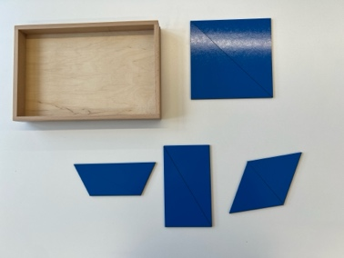**Rectangular Box B**

Materials:

* + A set consisting of one pair of each of the triangles described in Rectangular Box A. This time colored blue and without the black lines.

Presentation:

1. Remove all of the triangles from the box and set the box aside
2. Take the two scalene right-angled triangles and make a rectangle, slide it to the top left hand corner of the table
3. Take the 2 isosceles right-angled triangles, make a square, slide it up to beside the rectangle
4. Take the 2 equilateral triangles to make a rhombus, slide it up to beside the square
5. Take the small scalene right-angled triangle and the small obtuse angled scalene triangle and make a trapezium, slide it to the top of the table beside the rhombus
6. Mix them all up and invite the child to build them as you did
7. After the child has built them and slide them up to the top of the table slide the rectangle back down in front of you and the child

**"SLIDING"** (see diagram)

1. Keep the left side of the rectangle stationary at all times with the left hand
2. Slide the right half of the triangle with the right hand
3. Slide it down so that the vertices touch
4. Slide it across to the left so that the bases are touching, take your hands away to get a better view
5. Slide it again so that the vertices are touching
6. Slide it up so that the sides are touching
7. Slide it up again so that the vertices are touching
8. Slide it down again so that you are back where you started
9. Invite the child to do the same
10. Show the child how to slide the next figure (the second one)
11. Invite the child to slide it
12. The child can now slide the third figure (the rhombus) without having it demonstrated first
13. Show the child how to slide the fourth figure
14. Invite the child to slide the fourth figure

"FLIPPING & SLIDING"

This can be presented the same day if the child wants to continue working with the materials, if not it can be presented on another day when the child would like it

***the sides that are touching always remain touching

1. Flip the right side of the figure so that the back side is facing up, then flip it back over
2. Slide the figure down so that the vertices are touching, then slide it across
3. Flip the figure, then flip it back
4. Slide the figure to the left so that the vertices are touching, then slide it up so that the side are touching
5. Flip the figure, then flip it back
6. Slide the figure up so that the vertices are touching
7. Slide it back down into its original position
8. Invite the child to "flip & slide" the figures
9. When finished, ask the child to replace the triangles back into the box in the reverse order

The dark blue triangles are the original shape created from the blue triangles. The light blue triangles show the motion of sliding.

The black arrow indicates the first move of the slide.

The light gray triangles represent the triangles as they are flipped over.

**Exercise #1**:

* Same as in Presentation #1
* Printable Constructive Triangles - Rectangular Box B

Purpose:

**Direct**

* Show by sensorial impression that different triangles join together and form 4 sided figures or other triangles

Indirect

* Preparation for geometry; the child absorbs the fact that all plane geometry figures constructed with straight lines are composed of triangles; the exercises also show the equivalences of different figures and also show the rules for finding areas

Age:

* 4 to 6 years
* Once the child starts to combine the triangles together in exploration it is time to present the Triangular Box

###### Triangular Box

Materials:

* + 1 large equilateral triangle without black lines
  + 2 equal green scalene

right-angled triangles, black lines along the longer of the two sides enclosing the right angle

* + 3 equal yellow isosceles obtuse-angled triangles, black lines along both sides enclosing the obtuse angle
  + 4 equal red equilateral triangles - 1 with black lines on all sides, 3 with black sides on 1 side

Presentation #1:

1. Take out one by one:
   * 1 gray equilateral triangle
   * 2 green scalene right-angled triangles
   * 3 yellow isosceles obtuse-angled triangles
   * 4 red equilateral triangles
2. Place them on the table randomly
3. Isolate the gray equilateral triangle between you and the child
4. Match the 2 green scalene right-angled triangles on top of the gray triangle by matching the black lines
5. Slide the green triangle off of the gray one and up to the top left hand corner of the table
6. Take the 3 yellow isosceles obtuse-angled triangles and match them on the gray triangle by their black lines
7. Slide the yellow triangle off and place it beside the green triangle
8. Take the 4 red equilateral triangles and match them by their black lines on top of the gray triangle
9. Slide it off and set it beside the 2 other triangles
10. Mix them up and invite the child to build the triangles
11. Ask the child to replace the triangles back into the box in reverse

Exercise #1:

* + Same as in Presentation #1
  + Printable Constructive Triangles - Triangular Box

Purpose:

**Direct**

* + To show different ways of constructing an equilateral triangle

Indirect

* + Preparation for geometry

**Control of Error:**

* + Inherent in the materials
  + The black lines
  + The gray triangle itself

**Age:**

* + 4 to 4½ years

**Language:**

* + The child must have the experience with the material before the language is given to him
  + The language is given in a 3 period lesson
  + All of the language may not necessarily be given in one lesson

#1. **Gray triangle**

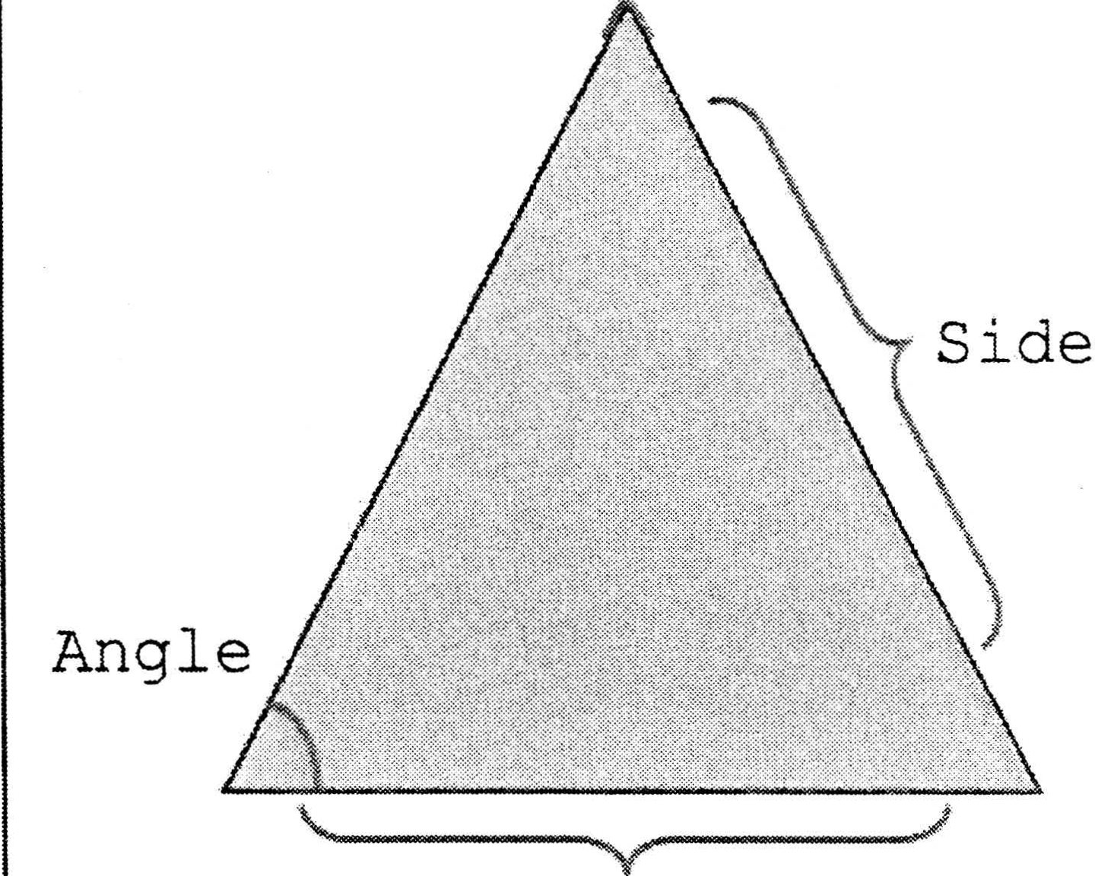

Vertex

Base

* + Side and angles
  + Use your fingers to point them out
  + You can turn the triangle and ask the child to show you a side or an angle, turn it again and ask the child to show you a side or an angle

#2. **Gray triangle**

* + Base and vertex
  + Use your fingers to point them out
  + Turn the triangle and ask them to show you the base and the vertex
  + Once they have understood the concept you

can ask for the sides and angles as well as the base and the vertex

* + You can also use another color of triangle and ask for the base and vertex

#3. **Green triangle**

* + Height
  + Use your finger to show the height of the triangle (the black line shows the height)

#4. **Yellow triangle**

* + Bisector
  + Use your finger to show the bisector of the triangle (the black line shows the bisector)
  + A bisector divides the triangle into equal sides

*the child should come to a realization that the lines drawn on an equilateral triangle divide into different types of triangles except the 4 red equilateral triangles which reproduce the gray equilateral triangle in a smaller size

* 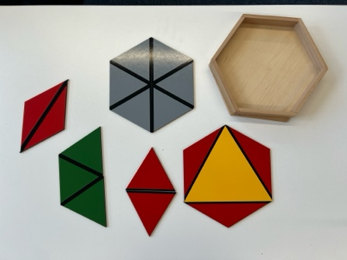Large Hexagonal Box

Materials:

* + 2 red isosceles obtuse­ angled triangles with a black line on the side opposite the obtuse angle
  + 2 gray isosceles obtuse­

angled triangles with a black line on one of the sides enclosing the obtuse angle

* + 6 yellow isosceles obtuse-angled triangles; 3 with a black line on the side opposite the obtuse angle, 3 with black lines on both equal sides
  + 1 large yellow equilateral triangle whose sides equal the longest side of the other triangles, with a black line on all three sides

Presentation #1:

1. At the table, remove all the triangles from the box and place mixed up on the table
2. Find the 2 red obtuse angled isosceles triangles and match them to make a rhombus. Slide it to the top left hand corner of the table
3. Find the 2 gray obtuse angled isosceles triangles and match them to make a parallelogram. Slide it to the top of the table
4. Isolate the yellow equilateral triangle to the center of the table
5. Isolate the 6 yellow obtuse angled isosceles; take the 3 with the black lines along the longest side and place along the sides of the yellow equilateral triangle
6. Flip those 3 obtuse angled isosceles triangles that were just placed on the side of the yellow equilateral triangle, over on to it
7. Flip them off again with the yellow side up
8. Take the 3 triangles that have the black lines that run along the equal sides, and place them on top of the yellow equilateral triangle Goin them by their black lines)
9. Once all three of them have been set down, place your hand on top of one of the triangles placed on top and slide it off along with the triangle that has been placed along its same side
10. Complete this for all three of the yellow triangles
11. Mix all of the triangles up on the table
12. Invite the child to have a turn
13. Bring down the red triangles and "slide" them
14. Replace at the top of the table
15. Invite the child to "slide" them
16. Bring down the gray triangles and "slide" them
17. Replace at the top of the table
18. Invite the child to "slide" them
19. Bring down the red triangles and "flip & slide" them
20. Replace at the top of the table
21. Invite the child to "flip & slide" them
22. Bring down the gray triangles and "flip & slide them"
23. Invite the child to "flip & slide them"
24. Ask the child how to replace them back in to the box in the opposite order

Exercise #1:

* + Same as in Presentation #1
  + Printable Constructive Triangles - Large Hexagonal Box

Purpose:

**Direct**

* + To show what figures can be built with the obtuse-angled isosceles triangles

**Indirect**

* + Preparation for geometry

Control of Error:

* + Inherent in the materials - the black lines

Age:

* + 4 to 4½ years

Personal Notes:

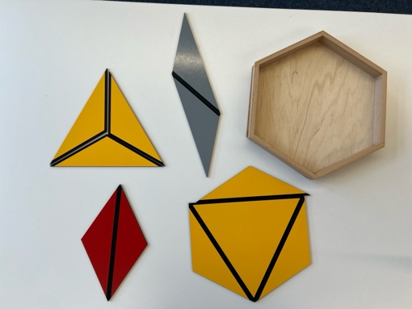Small Hexagonal Box

**Materials:**

* + 6 gray equilateral triangles with black lines on 2 sides
  + 2 red equilateral triangles with black lines on 1 side

3 green equilateral triangles; 2 with black lines on 1 side, 1 with black lines on 2 sides

* + 6 red isosceles obtuse triangles that have a black line on the side opposite the obtuse angle
  + 1 yellow equilateral triangle

**Presentation #1**:

1. Bring the box to the carpet
2. Remove all of the small equilateral triangles and place randomly on the carpet
3. Place the yellow equilateral triangle at the top left of the carpet
4. Take 2 of the red isosceles obtuse angled triangles and create a rhombus, slide it to the right of the yellow equilateral triangle
5. Repeat with the remaining 4 red isosceles obtuse angled triangles
6. Locate the 2 red equilateral triangles and connect them by their black lines
7. Move the new figure (rhombus) to the top of the table
8. Find the 3 green equilateral triangles, match them by their black lines (trapezium) and move it to the top of the table
9. Connect the 6 gray equilateral triangles by their black lines to form a small hexagon

10.Place one hand on the top of the hexagon and place the other hand at the bottom of the hexagon; split the hexagon in half by sliding the upper half away from the lower half to create 2 trapeziums (also referred to as trapezia)

1. Take your hands off and look at your creation
2. Reassemble the hexagon
3. Separate the hexagon in to 3 rhombi
4. Reassemble the hexagon
5. Mix all of the equilaterals up on the table
6. Invite the child to construct the them
7. When finished, have the child replace the triangles back in to the box into the box in reverse order

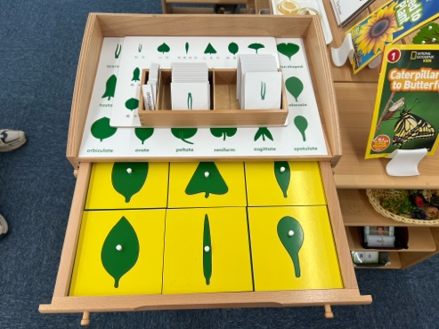Botany Cabinet

**Materials:**

* + Cabinet containing wooden frames and insets of shapes. Three sets of cards for the

cabinet: filled in, thick line, and thin outline. Orange stick.

Presentation #1:

1. The work with this cabinet is the same as with the geometry cabinet with the exception that the insets are not traced with the finger but with an orange stick (the inset clockwise and the frame counter clock wise)
2. The orange stick should be held properly as though it were a writing instrument
3. There are only three drawers and there is no presentation tray, the first drawer is used to present
4. Once the child has been presented the first tray he is free to work with the two remaining trays on his own when he pleases
5. The insets are materialized abstractions

Exercise #1:

* + Same as in Presentation #1
  + Printable Botany Cabinet Shapes 3-Part Cards, Botany Cabinet Control Charts, Botany Cabinet Cards (Thick, Thin, Filled In)
  + Printable Leaf Shapes & Leaves - sort photographic images according to their leaf shapes

Notes:

* + The child may trace around these insets with a pencil (held upright) being careful that the lead does not get all over the sides of the inset

Purpose:

**Direct**

* + Basis for classification of all simple leaves the child will find the basis for biological research
  + Visual and muscular discrimination of shape

Indirect

* + Preparation for writing
  + Preparation for biology

Control of Error:

* + Inherent in the materials

Age:

* + 3½ to 4 years

Language:

* Given as a three period lesson

Tray 1.

* Linear
* deltoid
* Orbiculate

Tray 2.

* Ovate
* Lanceolate
* Elliptical
* Obovate
* Reniform
* Spatulate

Tray 3.

* Obcordate
* Sagittate
* Hastate
* Cordate
* Aciculate

Games:

* As per the geometry cabinet cards; although the card break down will be considered smaller due to the fewer insets: 3/4/7
  + 1. Bring the card to the inset
  + 2. Bring the inset to the card
  + 3. Bring insets to the cards with some cards missing
  + 4. Matching cards with some cards missing
  + 5. Visually matching cards with some cards missing

Personal Notes:

# Tactile Sense



###### Touch Boards



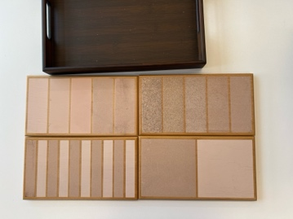Materials:

* 2 rectangular boards: Board divided in two, one half covered with rough sandpaper, the other smooth. Board divided into eleven narrow partitions; alternating smooth and rough.

Container for water, a rough fingertip towel and a tray.

Presentation #1:

1. Take the child to the sink and wash your hands
2. Take the child to the shelf and show him how to carry the touch boards, take them to the table
3. Go back to the shelf and have the child carry the sensitizing tray (with the water and the fingertip towel) to the table
4. Take the bowl off of the tray, ask the child to go to the sink and fill it with water
5. Wet your fingers into the bowl of water and rub them vigorously on the rough cloth (cause friction between your fingers and the cloth)
6. Fold the cloth so that the child has a new surface to sensitize his fingers
7. Bring forth the touch board with one smooth and one rough side, placing the smooth side to your left and the rough to your right
8. With your forefingers in a graceful movement of the wrist stroke the smooth side, stroke it again and say "smooth"
9. Repeat this with the rough side saying "rough" on the second stroke
10. Repeat again with both the smooth and the rough side
11. Invite the child to wet his fingers in the water and rub them on the rough towel, and then to stroke the smooth and rough board
12. Bring forth the touch board with the strips, placing the smooth strip to the left
13. Using on the first two fingers stroke each strip in turn, stroke, then say "smooth", stroke, then says "rough", stroke, then say "smooth", stoke then say "rough" etc.
14. Invite the child to have a turn

Exercise #1:

* + Same as in Presentation #1

Purpose:

**Direct**

* + Development of tactile sense
  + Control of muscular action by lightness of touch required (with tips of fingers)

Indirect

* Preparation for writing

Control of Error:

* Visual (shades of the sandpaper)

Age:

* 2½ years; these touch boards must be presented first before the touch tablets

Language:

* Give an informal language lesson
* Bring forth both of the boards with the two halves placed behind the board with the strips
* On the first board ask the child "can you touch smooth?", "Can you touch rough?"
* On the board with the strips ask the child "can you touch all of the smooth strips?", "can you touch all of the rough strips?"
* Point to a strip and ask the child to identify it, make sure the child strokes it and verbalizes what it is

**Personal Notes:**

###### Touch



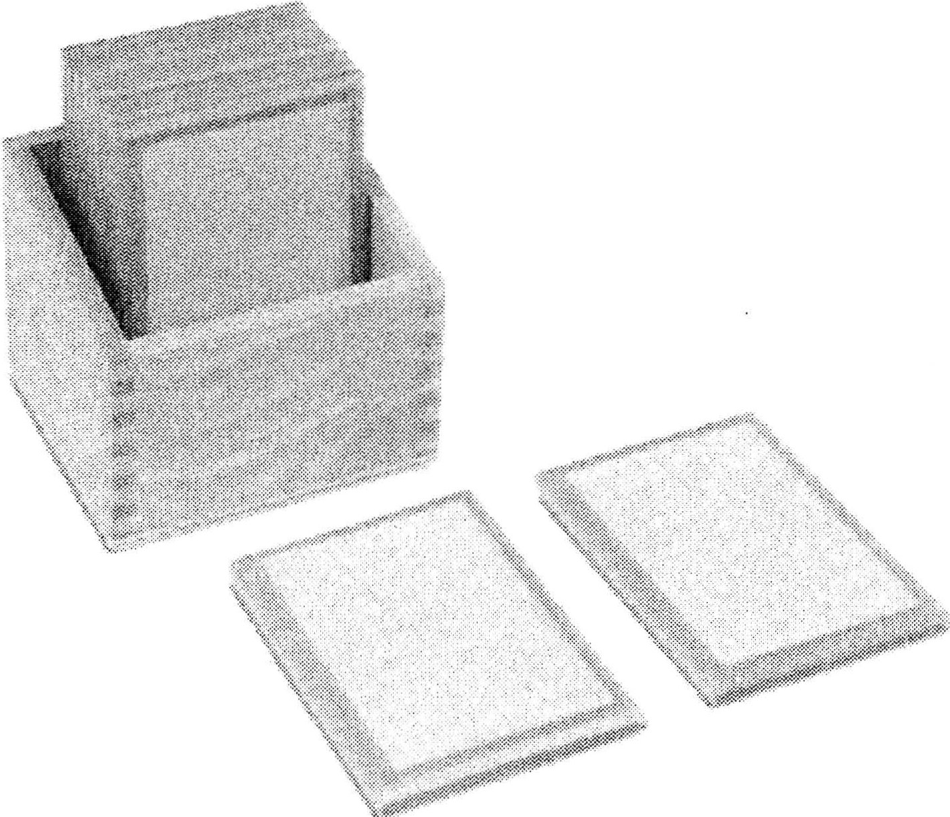Materials:

* A box containing five pairs of tablets of varying grades of sandpaper.

Presentation #1:

1. Show the child how to carry the tablets, the child carries the tablets to the table
2. Ensure that your hands, as well as the child's hands are clean
3. Bring all of the tablets to the table
4. Take one of each pair and stack them on the table

to the left of you, and then take the other of each pair and line them mixed up after the stack

1. Stroke the first tablet in the stack (stroke as with the touch boards), then move to the line of the tablets and stroke each one until the match is found
2. When the match is found, place them on top of each other and place the match to the top of the table
3. Invite the child to match the remaining tablets in the stack

Exercise #1:

* + Same as in Presentation #1

**Presentation #2:** - Match from a line with eyes closed

1. The setup is the same as in presentation #1, but the child keeps his eyes closed
2. The Directress does not present this - the child does it right away
3. After they are all matched the child can open his eyes and check his work

Exercise #2:

* + Same as in Presentation #2

**Presentation #3:** - Scattered on the table with eyes closed

1. All ten tablets are mixed up on the table
2. The tablets must be matched one at a time and placed aside in piles
3. The child's eyes remain closed until the end
4. After they are all matched the child can open his eyes and check his work
5. Invite the child to try

Exercise #3:

* + Same as in Presentation #3

**Presentation #4:** - Grade in order with eyes closed

1. Use only one of each pair
2. Scatter the 5 tablets on the table
3. With eyes closed, find the most course (roughest) tablet and place it at the top of the table
4. Then find the finest (smoothest) tablet and place it below the most course tablet, leaving room for the middle gradations
5. Grade the rest of the tablets and place then between the two tablets placed aside
6. When all the tablets are graded open your eyes and check the gradation; if any are out of order fix them, as the child will check his gradations against yours
7. Invite the child to grade the five remaining tablets; the child can open his eyes and check his work when he is finished

**Exercise #4:**

* + Same as in Presentation #4

**Purpose:**

**Direct**

* + Development of tactile sense
  + Control of muscular action by lightness of touch required (with tips of fingers)

**Indirect**

* + Preparation for writing

**Control of Error:**

* + Visual (shades of the sandpaper)

**Age:**

* + 2½ years; the child must be presented with the touch boards first

**Language:**

* + Already given with the touch boards

**Games:**

1. Matching at a distance (refer to the Color Tablets game), but the child must close his eyes when touching the tablets
2. Grading at a distance (refer to the Color Tablets game), but the child must close his eyes when touching the tablets

**Personal Notes:**

###### Fabrics

Materials:

* + A box or tray containing two of each of a variety of basic fabrics (silk, linen, cotton, wool), cut into identical squares. Each pair of fabrics is a different color or print.

Presentation #1:

Part 1 - Simple Matching

1. Sensitize the fingers with the sensitizing material prior to working with the fabrics
2. Mix of fabrics randomly on the table
3. With your eyes open, select a fabric and go through the process of feeling it
4. Hand it to the child and ask the child to feel the fabric, then set it down and find the match by feeling the other fabrics (the child will most likely match the fabric by the color or pattern)
5. Ask the child to choose another fabric and match it
6. Have the child continue until all of the fabrics are matched

Part 2 - Matching to one fabric - eyes closed

1. Mix up all of the fabrics on the table
2. Have the child close his eyes
3. Hand the child a fabric and ask him to feel it, then set it aside on the table
4. Hand the child one fabric at a time until he finds the fabric that matches the fabric that he had set aside
5. The child must put the 2 matching fabrics together and set them aside (*the child is not to go back to the fabrics that he has set aside, the child is to retain the memory of the fabric)
6. Complete this process until the child has matched all of the fabrics
7. The child can then open his eyes and check to see how many of the fabrics he matched correctly

Part 3 - Matching to two fabrics - eyes closed

1. Mix the fabrics and place them randomly on the table
2. Have the child close his eyes
3. Hand the child two fabrics (one in each hand)
4. Ask the child to feel both fabrics and then set them down
5. Give the child two more fabrics, one which matches one of the fabrics that he has just set down
6. Ask the child "Does either one of these two fabrics match either one of the two that you have just set down?" - the child should match one
7. Take the two that the child didn't match and mix them up with the remaining fabrics
8. Repeat this process until the child has matched all of the fabrics
9. The child then opens his eyes and can check to see how many of the fabrics he matched correctly

Part 4 - Matching one fabric from them all - eyes closed

1. Mix up all of the fabrics on the table
2. Have the child close his eyes
3. Ask the child to find one of the fabrics, feel it and place it aside
4. Ask the child to find its match and place the two fabrics together
5. The child continues this process until he has matched all of the fabrics
6. When finished, the child can open his eyes and check to see how many he matched correctly

Exercise #1:

* + Same as in Presentation #1, Parts 1-4

Purpose:

**Direct**

* + To furnish the child with the opportunity of refining the sense of touch

Control of Error:

* + Visual (shades and patterns of the different fabrics)

Age:

* + 2½ to 3½ years

Language:

* + Can be given in casual conversation with the child and will vary depending on your fabrics
  + Felt- pressed wool (from a Yak)
  + Silk - from silk worms
  + Cotton - cotton plant
  + Leather - animal rawhide

**Personal Notes:**

# Baric Sense

###### Baric Tablets

Materials:

* + 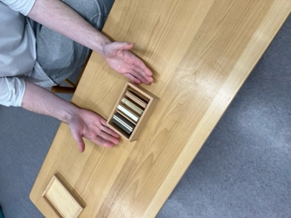A box with three compartments or a set of three boxes each containing six wooden tablets. Each set differs in weight and color. A blindfold.

Presentation #1:

Part 1 - Placing the tablets - eyes open

1. Ask child to carry the box to the table
2. Take the tablets out of the box
3. Set them into two piles (one set in each pile)
4. Take one tablet in each hand (the tablet rests on the fingertips with the hand slightly cradled, and the elbows remain at your sides)
5. After you have felt the different weight of the two tablets place them on the table to start two more piles (classifying heavy & light)
6. Ask the child to hold out his hands
7. Place a tablet in each of his hands and ask him to feel the weight of the tablet, then to place them into the piles appropriate to their weight
8. You can give him the tablets in alternating hands so that each hand has the opportunity to feel the difference in weight
9. When the child has held all of the tablets, return the tablets to where they were originally set

Part 2 - Placing in piles - eyes closed

1. Close your eyes and then ask the child to hand you a tablet into each hand; after you have felt the weight of the tablets place them into two piles on the table in front of you
2. The child hands you two more tablets and you determine in which pile each tablet belongs
3. Continue until the child has given you all of the tablets and you have placed them into two piles, when finished, open your eyes and look to see how many of the tablets were placed correctly
4. Ask the child to close his eyes and place his hands out; place the two of the alternate tablets in to his hands and ask him to place them in to piles; repeat with the second set. From the third set on, you can give the child alternate and like tablets and he should be able to distinguish the difference of the weight and place them in to the appropriate piles
5. When the child has held all of the tablets he can open his eyes and check to see how many he placed correctly

Part 3 - Child can work on own

1. Take the original two piles of tablets and mix them up to make two piles of alternating weights
2. Ask the child to feel the tablets with his eyes closed
3. The child takes one tablet from each pile and then sets them down to make two different piles
4. Once finished the child can open his eyes and check to see how many of the tablets are correct
5. This allows the child to be able to work with the tablets on his own

Exercise #1:

* + Same as in Presentation #1, Parts 1-3

**Presentation #2:** - Language

* + As per a three period lesson
  + Light & heavy is the language given
  + The medium tablets do not have any language
  + The language can be given one day when the child is working with the materials

Period #1

* + Ask the child to close his eyes and hold his hands out
  + Place a heavy tablet in one hand, and a light tablet in the other
  + Touch the child's hand with the heavy tablet "this is heavy"
  + Touch the child's hand with the light tablet "this is light"
  + You can alternate the tablets in the child's hand and repeat the above step

Period #2

* + Ask the child "where is heavy?", "where is light?"
  + "Can you place heavy here?", "Can you place light here?"
  + Etc.

Period #3

* + Ask the child to identify a tablet: "Please show me heavy"

Purpose:

**Direct**

* + Development of the baric sense

Control of Error:

* + Visual (color of the tablets)

Age:

* + 2½ to 3½ years

Language:

* + Same as in Presentation #2

## Stereognostic Sense

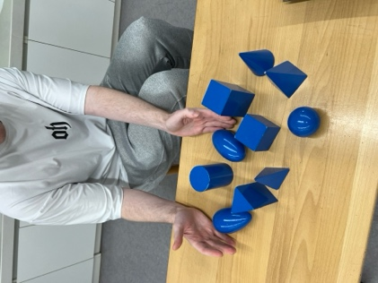

###### Geometric Solids

**Materials:**

* + Different solid geometric forms: sphere, ovoid, ellipsoid, cube, triangular prism, rectangular prism (parallelepiped), cone, square-base pyramid, triangular-base pyramid (tetrahedron), and cylinder. A set of

wooden tablets which have the same base as the rectilinear solids or the same shape as a horizontal cross-section of the curvilinear solids. A basket; an attractive cloth.

**Presentation #1:**

Part 1 - Feeling

1. This presentation can be given to three children at once
2. Bring the basket full of solids to a mat
3. Take the first solid out of the basket and feel all of the surfaces, curves, and planes, etc.
4. Hand the solid to the first child and invite him to feel it; the child, then passes it on to the next child to feel; the last child feels it and then sets it down on the mat
5. One by one the solids are set down onto the mat
6. After all of the solids have been felt by each child, they are replaced in the basket

Part 2 - Exploration & Superimposition

1. Take out one solid from the basket and isolate it on the mat in front of you
2. Explore the solid (i.e. Pyramid: try to knock it over its base by the point, then try to roll it around the point)
3. After the exploration invite the first child to explore the solid; rolling, toppling, rolling around its point
4. Continue to participate in the exploration for the first few solids to show the children the possibilities for the exploration, and then allow them to explore on their own
5. When all of the solids have been explored invite the children to superimpose them upon each other (i.e. the cone on top of the cylinder, the triangular prism on top of the rectangular prism, etc.)
6. Encourage all variations

**Exercise #1:**

* + Same as in Presentation #1

**Presentation #2:** - Cube & Sphere Classification

1. Have the basket with all of the solids in front of you
2. Place the cylinder and the cone off to your side
3. Take out the cube and have all of the children feel it and then set it down on the mat
4. Take out the sphere and have all of the children feel it and then set it down on the mat in an area away from the cube
5. Take another solid out of the basket, give it to a child and have him feel it and then place it in one of the two groups (either cube or sphere)
6. Continue on with the next solid, ask another child to feel the solid and place it into one of the two groups
7. Once all of the solids have been placed in either of the groups bring forth the cylinder and the cone (these two are put aside due to the fact that they are part curve surfaces and part plane surfaces; therefore they can go into either group)
8. The children may place these two solids in either or both of the two groups depending on their stereognostic sense

Exercise #2:

* + Same as in Presentation #2

**Presentation #3:** - Language Lesson

1. As per a three period lesson
2. With different children you will give different language and they will pass the language along
3. Sphere, ovoid, ellipsoid, cube, triangular prism, rectangular prism) (parallelepiped), cone, square-base pyramid, triangular-base pyramid (tetrahedron), and cylinder

Exercise #3:

* + Same as in Presentation #3
  + Printable Geometric Solids 3-Part Cards, Geometric Solids Command Cards, Geometric Solids Worksheets

**Presentation #4:** - Bases

1. Bring the basket and the box with the bases to the mat
2. Take the bases out of the box and the solids out of the basket and place them all on the mat* (the ellipsoid, ovoid and the sphere stay aside until all of the other solids have been superimposed)
3. Superimpose the solids on all of the bases; be sure to try all the variations possible; start off showing the children the first one and then invite them to superimpose the remaining ones
4. Invite them to take those ones off of the bases and try different solids on different bases
5. Once the children have exhausted all of the possibilities you can initiate the base work with the curvilinear solids by placing the sphere on top of the curvilinear base, the cylinder can be placed lengthwise on the rectangular base; with these three solids they must be viewed from a bird's eye view (looking directly down on top of them)

Exercise #4:

* + Same as in Presentation #4
  + Printable Geometric Solid Sorting Cards

Purpose:

**Direct**

* + To develop stereognostic sense
  + To familiarize the child with the geometric shapes around him

Indirect

* + Preparation for geometry

Age:

* + 3 - 3½ years

Language:

* + As in Presentation #3

Games:

**#1 - Reach Under and Name**

* + Participate with the children
  + Place all of the solids on the mat and cover them up with a cloth
  + Reach under the cloth and feel around, "I think that I've got.... a cube! (For example)
  + Ask the children "Did I get the cube?"
  + The solid is then placed aside
  + The children will take turns reaching under the cloth and naming a solid that he is about to bring out from under the cloth
  + Continue until all of the solids are out from under the cloth

#2-Find a...

* + All of the solids are placed on the mat and covered with the cloth
  + Ask the child to place his hand under the cloth and find a specific solid - "Could you please find the... sphere."
  + when the child brings forth the solid it is placed back under the cloth and the next child is invited to have a turn

#3 - Behind the Back

* + You can have up to ten children playing this game
  + The children sit around a mat and they hold their hands behind their backs
  + Walk behind them and place a solid in each child's hand - remind them not to look at their solid, just to feel it in their hands
  + Walk back to the front of the mat and ask them "which child has the cube? Could you

place it on the mat?"

* + When the child places the solid on the mat the next solid is asked for
  + This process of giving the children the solids and then asking for them is repeated until all of the solids have been used

**'#4** - **The Missing One**

* + All of the solids are placed on the mat and covered by the cloth
  + Reach your hand underneath; grasp a solid and as you bring the solid off of the mat and towards you, be sure to hold the cloth along with it so that the child are not able to see the missing solid but so that they can see the solids still on the mat
  + The children are then to guess which solid is missing
  + Once the children guess, the solid is shown to them and then it is placed back with the remaining solids and the cloth is placed over them
  + Invite one of the children to take one of the solids as you did; then keep inviting a new child to do the same

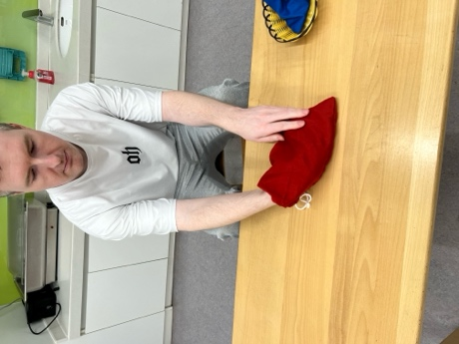**Mystery Bag**

**Materials:**

* + A bag made of fabric, containing a variety of objects.

**Presentation #1:**

1. Have the child carry the bag to the table
2. Place your hand into the bag and feel all around it inside
3. When you have your hand on something inside the bag tell the child what you think you have in your hand. "I think I have a key"
4. Close your eyes and pull the object out of the bag, ask the child "Did I get the key?" - he will answer you, you open your eyes and place the object at the top of the table
5. Repeat this process until all of the objects have been removed from the bag and placed on the table
6. Replace the objects back into the bag
7. Invite the child to open the mystery bag and remove the objects one at a time as you did

**Exercise #1**:

* + Same as in Presentation #1

**Notes:**

* + There may also be another bag in the classroom for the older children (4 1/2 - 6 years), the objects would combine all of the senses; baric, thermic, and stereognostic

**Purpose:**

**Direct**

* + Training of the stereognostic sense
  + Development of the power to visualize mentally

**Control of Error:**

* + The objects themselves

**Age:**

* + 2½- 3 years

**Personal Notes:**

# Olfactory Sense

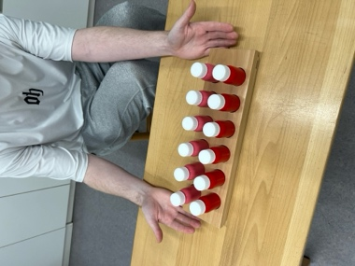

Part 1 - Matching

1. Blow nose first to clear the passage ways, invite the child to blow his nose
2. Remove the containers from the tray, placing the yellows containers randomly in one line, and the black randomly in another line
3. Take the first container from the left, isolate it, open it up, hold in front of your nose and waft it (wave your hand over the bottle, directing the air flow towards your nose). Waft it under the child's nose, replace the lid and set it aside
4. Take the first bottle on the right, open it, waft it, waft it under the child's nose
5. Ask the child "does this smell the same?" If it doesn't, place it at the back of the line on the right, and then take another container from the front of the right line. If it does smell the same, place it beside the isolated box and set the two aside
6. Take another container from the left, isolate it, open it and waft it under your nose and the child's nose
7. Take a container from the right, open it, and waft it under your nose and the child's nose. Ask "Does it smell the same?" If it does smell the same, pair the two and place them aside. If not, place to the back of the right line and take another from the right line
8. find the match to the remaining containers

Part 2 - Language

* + Set one pair of the containers off to the side
  + Open the first container, waft it under your nose and then the child's nose; "This is

...Vicks Vapor Rub (medicine)/garlic/perfume. "Can you say that?"

* + Repeat with the remaining containers

**Exercise #1**:

* + Same as in Presentation #1

**Notes:**

* Can use pairs of sachets containing different herbs or spices
* Young children can be scared to taste/smell unknown substances - there must be trust between the child and adult
* Humans can detect 7 primary odors that help them determine objects: camphor (mothballs), musk (perfume/aftershave), floral (roses), peppermint (mint gum), ether (dry cleaning fluid), pungent (vinegar), and putrid (rotten eggs)

**Purpose:**

**Direct**

* To make the child conscious of the various perfumes and odors that surround him

**Control of Error:**

* Within the child (his growing discrimination)

**Age:**

* 3½ years

**Games:**

1. Matching at a distance
   1. Place 1 set of bottles on one table, and the other set on another table at a distance
   2. Smell a bottle from one table and try to find the match at the table a distance away
2. Matching to smells in the environment
   1. You will need containers that have hand lotion, shoe polish, brass polish, etc.
   2. Take the smelling box to the object (i.e. The hand lotion box to the hand lotion at the sink
   3. Take the object to the smelling box
3. Game in exploration
   1. Walk outside and smell the air, the flowers, the seasons etc.
4. Role of the sense of smell and taste
   1. Have the child pinch his nose
   2. Place a piece of fruit or vegetable in the child's mouth
   3. Have the child guess what it is
   4. Have the child release his nose and taste what the fruit or vegetable really is

**Personal Notes:**



# Auditory Sense

###### Sound Boxes

Materials:

* Two boxes, each containing six cylinders, one set with red tops, and one set with blue tops. Each pair of cylinders makes a different sound when shaken.

**Presentation #1:** - Matching

1. Take both boxes to the table
2. Place the cylinders onto the table in two parallel lines (randomly)
3. Isolate the first cylinder on the left, take it to your right ear and shake it 3 times, take it to your left ear and shake it 3 times
4. Place it down in between you and the child
5. Take the first cylinder on the right
6. Shake it to your right ear 3 times, then to your left ear 3 times
7. Ask the child "Does that sound the same?"
8. If it doesn't sound the same, then place it to the back of the line on the right, and then take the next cylinder from the right & shake
9. If it does sound the same, then set it beside the isolated one and then place the two of them off to the side
10. Continue on until all of the cylinders are matched according to their sounds
11. When all of them are matched mix them up and invite the child to match them as you did

Exercise #1:

* + Same as in Presentation #1

**Presentation #2:** - Grading

1. Ask the child to set the cylinders out in two lines in random order
2. Set one color aside
3. Shake each cylinder until you find the loudest one; set it at the top of the table; tell the child "This is loud", the child should repeat the word loud
4. Shake the remaining cylinders until you find the softest sounding cylinder; tell the child "This is soft", the child should repeat the word soft
5. Grade the remaining cylinders in between the loudest and softest cylinder
6. When finished the grading check the cylinders by starting at the softest
7. Bring forth the other pair of the cylinders and invite the child to grade them and when finished he should check his work

**Exercise #2:**

* Same as in Presentation #2

**Purpose:**

**Direct**

* Training of the auditory senses
* Training of the memory and attention

**Control of Error:**

* Within the child

**Age:**

* 3 to 3½ years

**Language:**

* Given in Presentation #2: loud and soft

**Games:**

1. Matching at a distance
   * Place 1 set of bottles on one table, and the other set on another table at a distance
   * Smell a bottle from one table and try to find the match at the table a distance away
2. Grading at a distance
   * Place 1 set of bottles on one table, and the other set on another table at a distance
   * Shake a bottle from one table and try to find the match at the table a distance away
3. Listening Game
   * Identify sounds with eyes closed (i.e. Door closing, light switch, stapler stapling, water running, sounds in the environment
   * Make sounds in various locations in the room and have the child identify where in the room the sound is coming from
   * Close your eyes and identify the natural sounds in the classroom or outdoor environment

**Purpose of the Games**

* Training of the memory and attention
* Training of the ear

**Personal Notes:**

###### The Bells

**Materials:**

* A series of bells in duplicate, from Middle C to High C. One complete set is mounted on brown stands, the other on white stands in the case of the tones, and on black stands in the case of the semi-tones. They stand on a board marked with black and white spaces corresponding to the

black and white keys on the piano. A wooden mallet; a mute.

**Presentation #1:** - Exploration

1. This is an exercise that should be presented to the children early on in the year, along with the other preliminary exercises
2. Tell the children that they must never move the white bells
3. As well, tell the children that they must not touch or polish the bells because the bells are sensitive to touch and may change tune
4. Show the children how to carry the bells to a table, holding the stem near the base with one hand and placing the other hand underneath the base
5. Show the children how to strike the bell; use the mallet in a pendulum motion and strike the rim of the bell in order to achieve a nice sound
6. Show the children how to mute the bell by placing the mute on the bottom rim of the bell
7. Have the children strike the bell loudly, and softly, allow the bell to ring without muting it and listen until the ring is no longer perceptible etc. (exploration)
8. Have the children hum the sound just after the bell has rung for a few seconds, allowing the sound to penetrate into the ear first (this should be something that the children do after each time they strike the bell)

**Exercise #1:**

* + Same as presentation #1
  + Encourage the children to eventually take each bell one at a time from the shelf to experiment with
  + When the child returns the bell to the shelf have him strike the bells up and down the scale so that the child hears the bells in their sequence

**Presentation #2:** - Matching

1. Take 3 brown bells from the scale that are fairly far apart from each other (i.e. do, fa, la), mix them up and place them in front of the remaining bells
2. Using the mallet strike one of the white bells that corresponds to one of the three brown bells that were removed and mixed up
3. Pause for a few seconds to keep the sound of the bell in your head and then strike one of the three brown bells to see if it matches
4. When the match is found for the white bell place it back into its correct position in the scale
5. Repeat this for the remaining two brown bells
6. When all three are matched, play up and down the scale of the brown bells in order to check the sequence of the three bells replaced (make sure that you hum up and down the scale in order to firmly imbed the sequence of the scale in your mind)
7. Remove the same three brown bells, have the child turn around while you mix them up and place them in front of the remaining brown bells
8. Invite the child to match the bells as you did
9. If the child is successful and wished to continue you can have him set the exercise up in the same manner adding one or two more bells to match •

Exercise #2:

* + Same as presentation #2

**Presentation #3:** - Grading the scale with a control bell

1. The child must know the scale well in order to proceed with this presentation (the succession of the diatonic scale must be firmly planted in their minds)
2. Take all of the brown bells and mix them up in front of the marked board
3. Tell the child that you are going to make the scale
4. Strike the first white bell and then strike all of the brown bells until the match is found, place the match in the correct position
5. Without referring to the white bells anymore (do not strike the white bells again)
6. Refer only to the last brown bell placed in order to find the next brown bell in the sequence
7. When all of the brown bells have been placed in sequence strike up and down the scale

humming after each bell has been struck

1. Invite the child to grade the bells in scale as you did

Exercise #3:

* + Same as presentation #3

**Presentation #4:** - Grading the scale without a control bell

1. Remove all of the brown bells and place them mixed up in front of the marked board
2. Without striking any of the white bells place the brown bells in order by striking them until the lowest sound (low Do) is found
3. Place this bell in position on the marked board and continue this procedure of finding the next bell in the sequence until all of the bells have been placed
4. Strike up and down the scale humming after each bell has been struck
5. Invite the child to grade the bells as you have just done

Exercise #4:

* + Same as presentation #4

**Presentation #5:** - Straight placement in the scale

1. Remove all of the bells and mix them up, placing them in front of the marked board
2. Strike one brown bell and place it directly onto the marked board in the correct sequence of the scale
3. Continue this process of placing the bells into the correct sequence until all eight bells

have been placed

1. Strike up and down the brown bells in order to check the sequence of the scale
2. Invite the child to grade the bells as you have just done

**Exercise #5:**

* + same as presentation #5

**Presentation #5:** - Language

* + Select 3 contrasting bells and set them out in front of the remaining bells (i.e. do, fa, la)
  + Give the child a brief 3 period lesson with these 3 bells
  + Ring 'do', tell the child - "This is called do" - have the child repeat after you
  + Repeat the above for "fa" and "la"
  + If the child is still, concentrating and wishes to continue, then do so... if not, leave the next 3 for another day

**Exercise #6:**

* + Same as presentation #6

**Purpose:**

* + Discrimination of pitch

**Control of Error:**

* + The scale itself and the white bells

**Age:**

* + 3 - 6 years, continuous learning process

**Games:** - Matching at a distance

1. **One bell at a time**
   1. Take all of the brown bells and place them randomly on a table a distance away from the white bells
   2. Strike one white bell and then walk to the table where the brown bells are
   3. Strike each brown bell until you find the correct match to the white bell that was struck
   4. Take the match back to the marked board
   5. Strike another white bell, go to the brown bells and find the match
   6. Once all of the bells have been matched, strike up and down the scale
2. Two bells at a time

* Using the same procedure as game #1, with the exception that two white bells are rung (one after the other) and you must find both of the matches at the same time (need to remember the sounds of both in your head as you search for the match)
* Once all of the bells have been matched strike up and down the scale

1. Ring one bell and take a walk

* Strike one white bell, take a walk through the environment (with a purpose such as going into the bathroom and turn the light off and on) and then return to the brown bells and find the match
* Once all of the bells have been matched strike up and down the scale

1. Place the bells around the environment

* Place the brown bells around the environment
* Strike a white bell and then find its match somewhere in the environment
* Place the bells in the correct position
* Once all of the bells have been matched, strike up and down the scale

1. Removal of the white bells

* Using 16 children
* Each child takes a bell from the shelf (including all of the white bells)
* Tell the children that this is the only time that they will remove the white bells from the shelf
* Have the children stand in a circle with the brown and white bells randomly between them
* Have one child walk around the circle striking each white bell; tell the children with the brown bells to listen carefully as they will eventually have to try to find the match to their bell
* Have another child walk around the circle striking each brown bell; tell the children with the white bells to listen carefully as they will have to find their match
* After both sets of bells have been struck ask the children to find their match and stand opposite to that child (in two lines)
* Have one child walk up between the two lines striking one bell of the match at a time so see if the match is successful
* Then ask the children to place themselves in scale for each color
* Have one child strike up the scale of the white bells and then down the scale of the black bells
* Have the children with the white bells, place them back on the marked board in scale, and then have the children with the black bells place them on the board as well
* Have a child strike up and down the scale one last time to ensure that they have all been placed correctly

**Personal Notes:**

###### Listening to Music

It is important that the children have the opportunity to listen to a great selection of music throughout their time in the Casa. This includes all of the Classical, Folk, Country, National Dance Music, etc.

Music can be played for the entire class on occasion while the children have some quiet work to do. This is probably best just after lunch as the children need some time to settle in to work. Before the music is played the children must be told what the piece is called, who the composer is, and any other information that the children will find interesting (any little stories behind the music).

If music is played on a constant basis is becomes background music and the children will just block it out. Choose the time for listening to music carefully so that it is treasured.

Play for the children, music that is related to any Culture, Geography, or History project that they are working on. This helps to give the children a greater feel, appreciation and understanding for the project at hand.

##### Musical Instruments

On the walls in the Casa there should always be some beautiful prints. The children will love to look at a print on the wall of the various instruments that will make music. The children will learn the names of the more familiar instruments, and learn some new ones as well.

There should be classified cards of instruments that the children can learn. There can be definition sets of a few of them. A selection of printable music-related cards should be available (composers, instrument nomenclature, picture cards).

In the library there should be a section on music, instruments, composers, and the history of various cultural music genres.

As well, there are tapes that focus on the specific sounds produced by each instrument in the Orchestra - "Ustinov and Britten on the Instruments of the Orchestra".

A great experience for the children is a guest composer/musician. A short visit from an experienced musician who will speak to the children and play some music for them on his instruments will bring music alive for the children. Encourage the visitor to tell the children any information regarding the history of the piece of music, the instrument etc.

###### Rhythm

Clapping is an excellent way for children to become a part of the composition of music. It is important to show children how to clap so that they don't hurt their hands, or make harsh sounds. Use the fingertips of the one hand and clap them onto the palm of the other hand.

* The Directress makes a short clapping rhythm; the children listen carefully to it. The children are asked "Together as a group would you please clap the rhythm back to me." The children repeat the rhythm. This can continue on his the rhythms getting longer and more complex as the children gain more experience with remembering the rhythms.
* The children form small groups and compose a rhythm together. They practice it until it is perfect. Each group will then separately clap out their group rhythm. The Directress will lead all of the groups; the first group claps their rhythm when they reach the end they will continue to clap it over and over again, however the second group will join in with their rhythm. When the second group has finished clapping their rhythm once, the third group will now join in a start to clap their rhythm (there will now be 3 groups clapping their own rhythms). Each group continues to join in with their own rhythm until all of the groups have joined in. The Directress stops the class by ending the first group when they reach the end of their rhythm, and then will stop each group in order as they reach the end of their rhythm.

V\/alking on the Line to Music

This is only presented to the children after they are walking well around the environment and on the line. Music can be played while some children are walking on the line. Allow the children to move spontaneously, they will start to move their bodies to the rhythm eventually. In no way should you try to make the rhythm clearer to the children by clapping it out and emphasizing the beginning and ending to the rhythm. Allow the children to find it on their own.

###### Dancing



This too, is only presented to the children after they are walking well around the environment and on the line. Children love to dance, and teaching them a variety of dances will help them socially, and it will also enhance their Cultural, Historical, and Geographical knowledge. A guest/parent that knows specific dances that the children could learn would be a great way for a parent to help out a class/school. If children are taught how to dance while they are young they will not be insecure or embarrassed to dance while in the adolescent years.

